ASSIGNMENT 2: THE IT WORLD

INTRODUCTION TO INFORMATION TECHNOLOGY

RMIT UNIVERITY VIETNAM

Group Name: The TAQ Team

Group Members:

* Nguyen Thanh Tuan (s3836455) (Lead)
* Giang Ky Anh (s3812288)
* Ngo My Quynh (s3836322)

I declare that in submitting all work for this assessment I have read, understood, and agree to the content and expectations of the Assessment declaration.

Table of contents

Table of Contents

Team Profile5

Team Name5

Personal Information5

Team Profile8

Tuan’s Profile8

16Personalities Test - Mediator8

Learning Style Test - Visual9

Creativity Test - 67.1310

Anh’s Profile10

Quynh’s Profile12

Ideal Jobs14

Tuan’s Ideal Job14

Anh’s Ideal Job16

Quynh’s Ideal Job18

Ideal Jobs’ Analysis19

Career Plans’ Analysis19

Tools21

Industry Data22

Tuan’s insights in industry data22

Anh’s insights in industry data23

Quynh’s insights in industry data24

IT Work26

What kind of work is done by the IT professional?26

What kinds of people does the IT professional interact with? Are they other IT professionals? Clients? Investors? The general public?26

Where do the IT professionals spend most of their time?27

What aspect of their position most challenging?27

Can you give me 3 words to describe IT industry?27

IT Technologies29

Cybersecurity - Virtual Dispersive Networking29

Blockchain and Cryptocurrency36

Machine Learning45

Robots56

Project Ideas69

Overview69

Motivation69

Description69

Tools and Technologies71

Skills Required71

Outcome72

Feedback73

Tuan’s Feedback73

Anh’ Feedback73

Quynh’s Feedback75

Group Reflection77

Tuan’s Reflections77

Anh’s Reflections77

Quynh’s Reflections78

Group Reflections79

References81

***Team Profile***

**Team Name**

Our team believes that knowledge only comes to those who seek it and asking questions is the first step toward erudition. By combining the first letter of our team members’ first names (T for Tuan, A for Anh, and Q for Quynh), we have TAQ, our team name, which also stands for “Time to Ask Questions”. The spirit behind this name is to promote and encourage others to be curious and not afraid to ask questions because that is when they have the potential to master what they want to learn.

**Personal Information**

***Nguyen Thanh Tuan***



I am Nguyen Thanh Tuan, a member of the TAQ team and a current student at RMIT University Vietnam. My student number is 3836455. I was born and raised in Ho Chi Minh city. In 2014, I travelled to the United States of America for higher education. However, things did not go as planned so I came back and applied to RMIT University Vietnam to continue my studies. I am majoring in Information Technology. I studied Business for a while when I was living in the States. During that time, my host family sparked the love of IT in me when he taught and guided me through the process of building my own computer. After my first build, I decided to officially switch my major to IT and dig deeper into it. I figured out that I am really into Networking, Cyber Security, and Database/Server. Although I do not have a lot of experience in the IT field beside some knowledge about computers, and coding, I am eager to learn more and make a career out of it, or even a business. During my free time, I love to hang out with friends; it can be anything from getting a cup of coffee, travelling with our bikes, or even playing video games together.

***Giang Ky Anh***



My name is Ky Anh, member of the TAQ team, first year student of RMIT in Saigon campus and my major is IT. Therefore, I was studying International Business at Hanoi campus. When finishing the first semester, I found out that business does not suit me well, so I changed the course. Having known that I had interest in technologies and the Internet, I decided to move to Saigon campus without hesitation. In the Information Technology area, things that attract me the most are Artificial Intelligence, Robotics, and Technologies. Furthermore, when seeing these things, the first thought in my mind is “what features does it have and what can it do?”. I always wanted to try new technologies not with speech from the others but by my own hands, because by interacting directly with these technologies I can easily memorize their features and how to manipulate them. Nevertheless, besides the love for technologies, I also have some IT experience when I have not graduated from my high school. At this time, the school itself has organized a science fair at the school hall. This fair includes all students from different ages to participate, by forming in a group of 5 members and creating an invention of their own, this could be anything, but most students chose to make a robot instead. Therefore, our group has invented a robot that can pick up items by using a controller but unfortunately it only can move around but cannot pick up items nearby.

***Ngo My Quynh***



Hi, my name is Quynh, but you can also call me Lam, I am a freshman at RMIT, and my student ID is s3836322. I am the third member of the TAQ team. So, let us talk a little bit about me. Firstly, I was born on a very, very special day, which is Women’s National Day. Sadly, I just have one gift on this day. Secondly, as you can see in my name, I was born in Vietnam. However, I can speak English too thanks to my parents because they made me learn English at a very young age. Thirdly, there is one fun fact about me: my brother and also my cousins used to call me “Quan”, which means trouser in Vietnamese, because my name has a similar pronunciation. Moreover, in my free time, I love reading books and learning new things in different aspects such as marketing, business, etc. If you ask what my interest in IT is, it is AI. I have a huge passion for AI because I am a lazy person and with the help of AI, my work will be completely faster and more efficient. To make my dream come true, I have studied some courses relevant to AI and machine learning on Linked Learning. Moreover, I have attended many classes to learn about algorithms and data structure. Furthermore, to expand my knowledge in this field, I have read many books relevant to AI, machine learning and data.

**Team Profile**

***Tuan’s Profile***

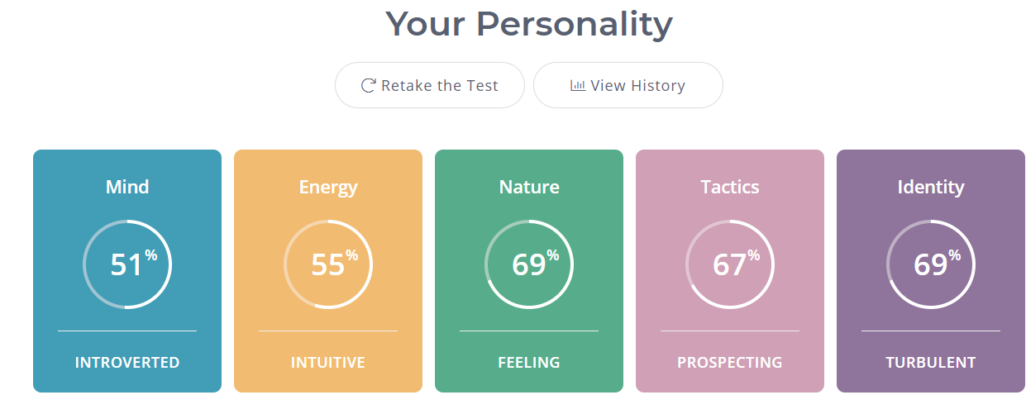

*16Personalities Test - Mediator:*

After reading through the analysis of the Mediator personality type, I start to understand more about myself and the traits and connections of my personality with others. These traits can both positively and negatively affect the efficiency of our group’s project. Firstly, I truly believe in harmony, and this trait is mentioned a lot in the analysis. I do not like conflict and prefer a mutual agreement on everything. As a harmony “guardian”, it is my job to keep the group friendly, comfortable, and connected. I can help dealing with conflicts and easing the tension whenever it may happen. On the other hand, this means that I can sometimes take these conflicts or problems too personally, which may cause me to hold back and slow down the group’s progress. Another important trait is the need of connection with the work that I am doing. As a Mediator, it is important for me to have a good connection with my work, both emotionally and morally. Mediators only show their true potentials when they truly believe and love the things that they do. However, it is also a critical point to the group if I am not into the project, which I am doing with them. It may negatively affect the outcome of the project and the connection with other group members.

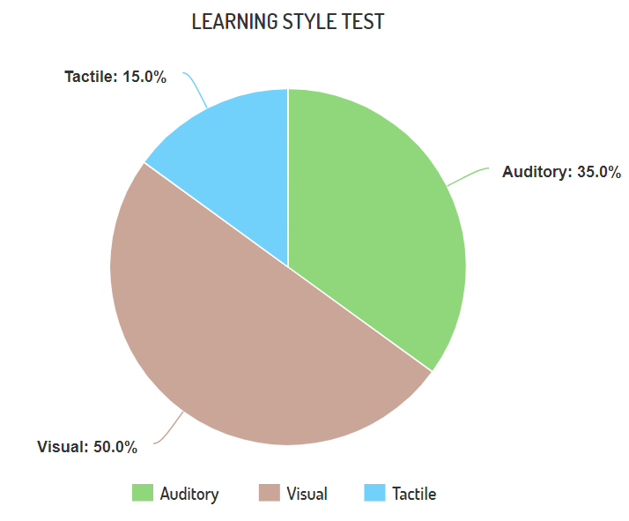

*Learning Style Test - Visual:*

As the results from the test shows, I am 50% Visual, 35% Auditory, and 15% Tactile. This means that it is easier and faster for me to learn something by looking. As I am “attracted to color and to spoke language (like stories) that is rich in imagery.”, it is important for me to write down keywords, brainstorm, take note and color code my work. In other words, to make the most out of my work in our group’s project, it is best for me to visualize things as I need to see things to learn it well.

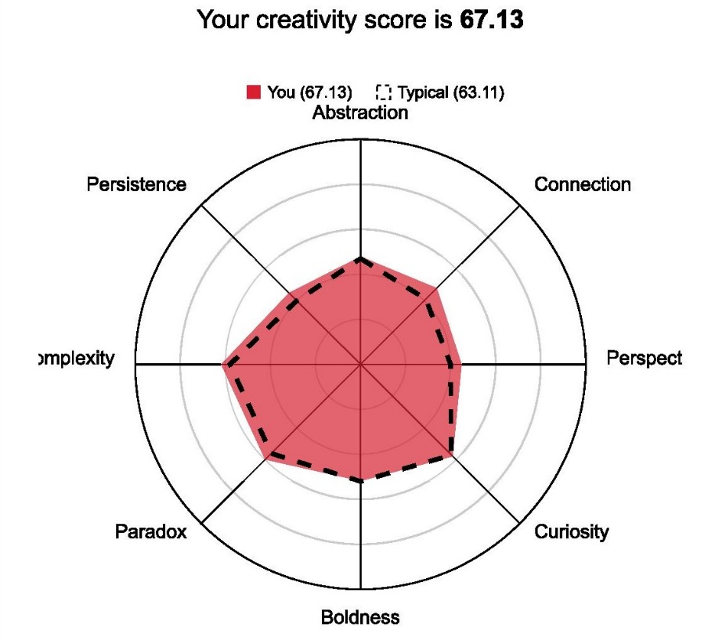

*Creativity Test - 67.13:*

My score for the creativity test is 67.13, which is slightly higher than a typical person in every field. In my opinion, this means that I am not likely to have an ‘out-of-the-box’ idea that can ‘revolutionize’ our group project. However, I do believe that there are a lot of variables that can affect one’s creativity/imagination, for example, one’s knowledge of the subject. So, it is hard to say that I will not be able to contribute much in terms of creativity.

***Anh’s Profile***

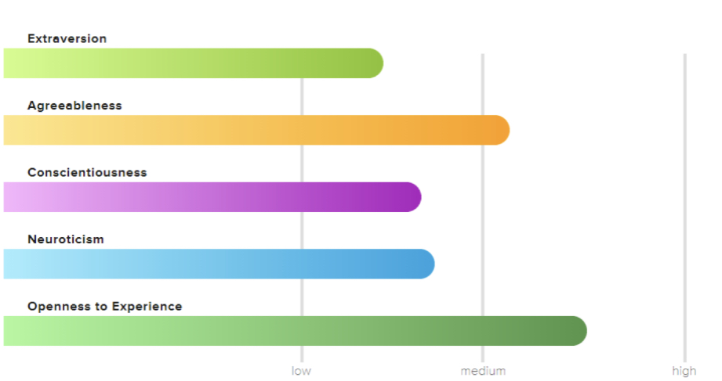

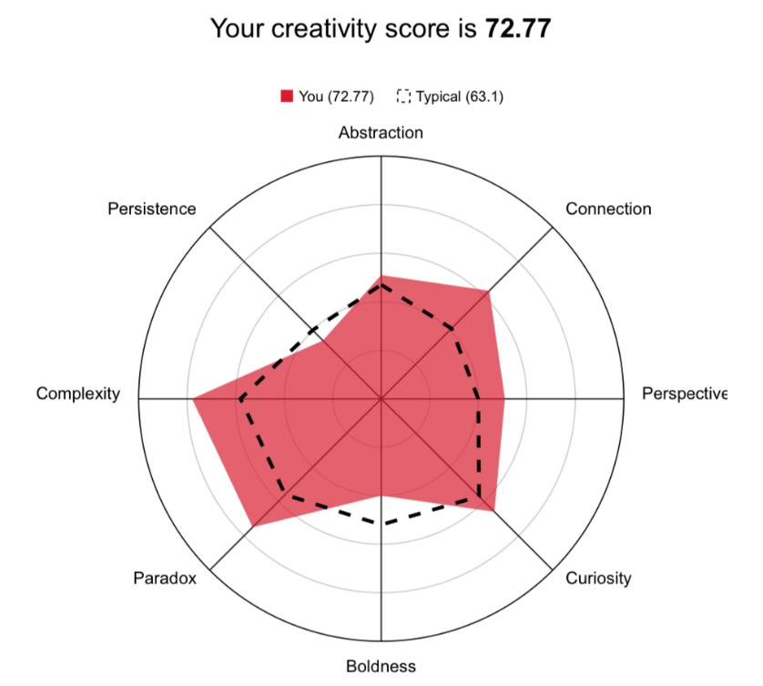

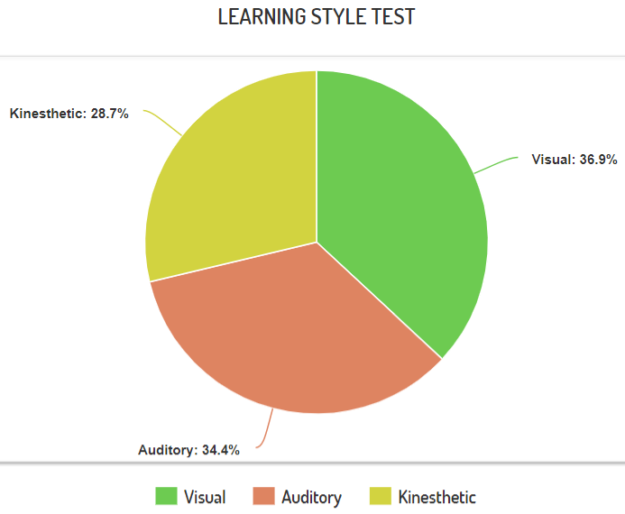

When forming in a group, these results from three tests will be a huge support for me when finding a group for myself. In these results, for example the Creativity test, I have a low in Persistence and Boldness. Therefore, I have a problem with pushing myself forward when doing projects and afraid that the group projects will receive a low grade because of my contribution. Moreover, I rarely express my thoughts to others which results in my members unable to support me. So, when forming a group, I must express my thoughts more, ask for others if I do not understand what my task is so they can support me and push me forward.

***Quynh’s Profile***

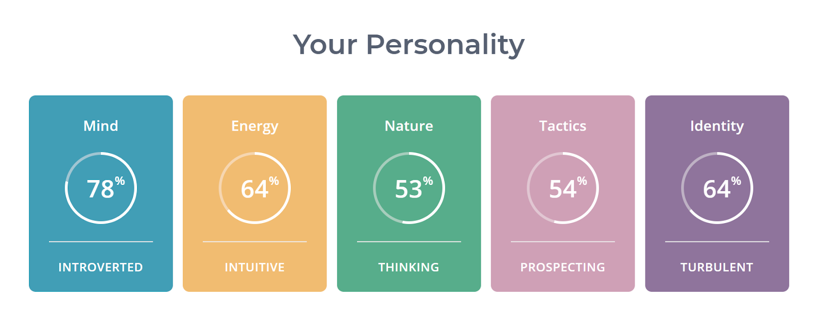

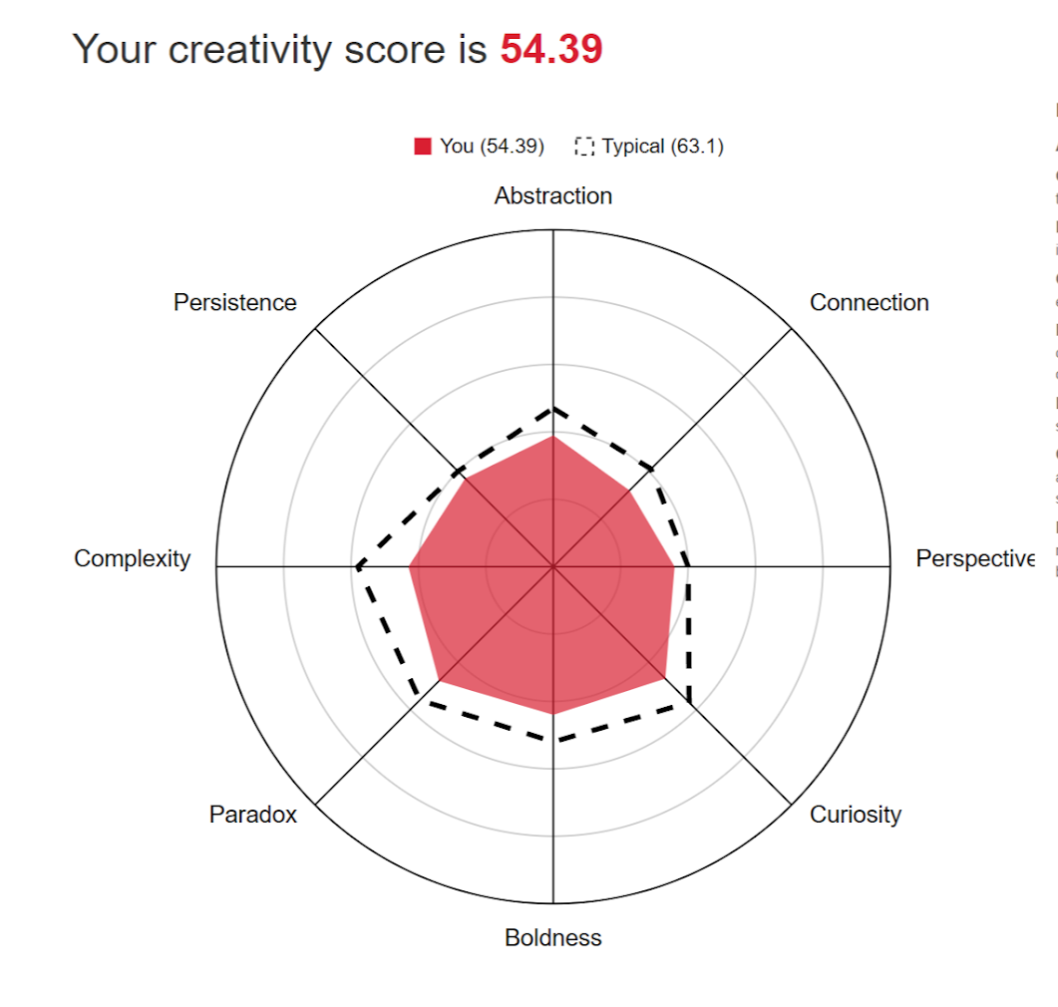

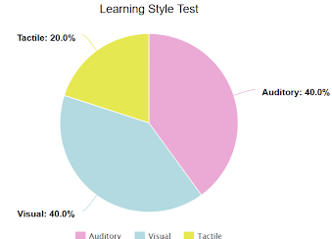

I do not understand myself quite well, so these results of personality tests have a big meaning to me. It helps me to acknowledge myself and improve my weakness. In the “16 Personality test”, according to the result, it shows my strength and weakness. Thanks to the test, I can know what I am good at and make beneficials from that. In the second test about “Learning style”, this test is important because it helps me to understand which the best method is to study effectively. Finally, the third test, which is “Creativity test”, shows me what I am lacking and because of it, I know how to improve myself. Overall, all these tests are very helpful information to our group because each member can know each other's strengths and weaknesses. As a result of that, we can support what skills the others are lacking and learn new things from each other to develop not only technical skills such as knowledge about programming but also soft skills such as how to work in a team or how to speak in front of people.

**Ideal Jobs**

***Tuan’s Ideal Job***

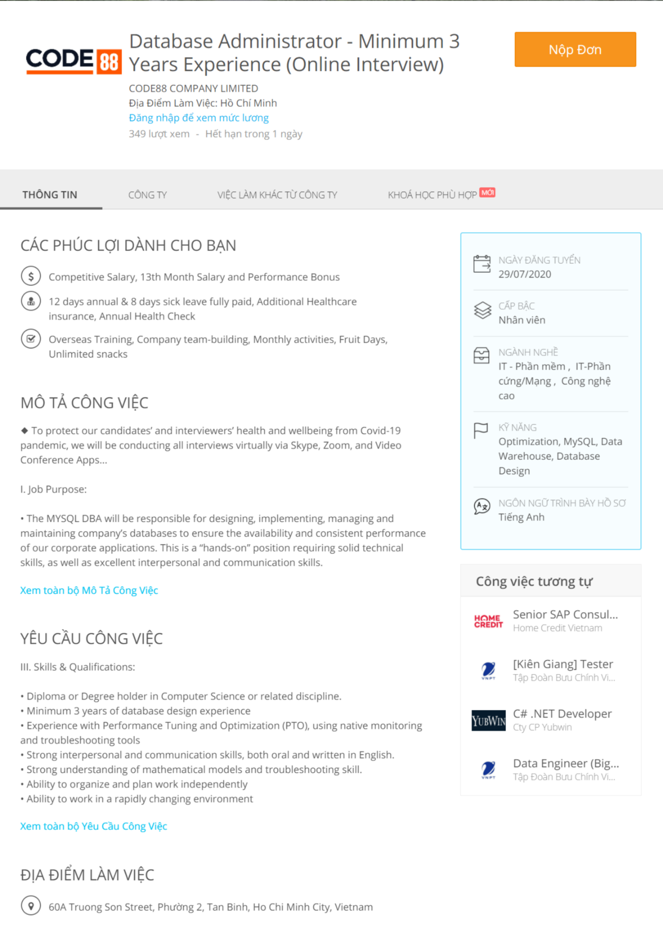

1. Ideal job: Database Administrator (Link to the website)

2. Job's plan:

* Diploma or Degree holder in Computer Science or related discipline => Currently studying at RMIT with a major in Information Technology
* Minimum 3 years of database design experience
  + Internships and side-projects will help me build the experience for this requirement. Experience with Performance Tuning and Optimization (PTO), using native monitoring and troubleshooting tools
  + Practice makes perfect: spending time to study and practice these and other tools in the field of Database
* Strong interpersonal and communication skills, both oral and written in English.
* Strong understanding of mathematical models and troubleshooting skill.
* Ability to organize and plan work independently
* Ability to work in a rapidly changing environment
  + Attend clubs, doing projects/events, schedule planning, ...
* Strong knowledge of MYSQL, stored procedure, trigger, event, indexing, and replication.
* Knowledge of database warehousing/clustering or mysql 8.0 group replication is a plus.
  + Self-study + in-class study about MYSQL, doing projects, ...

***Anh’s Ideal Job***

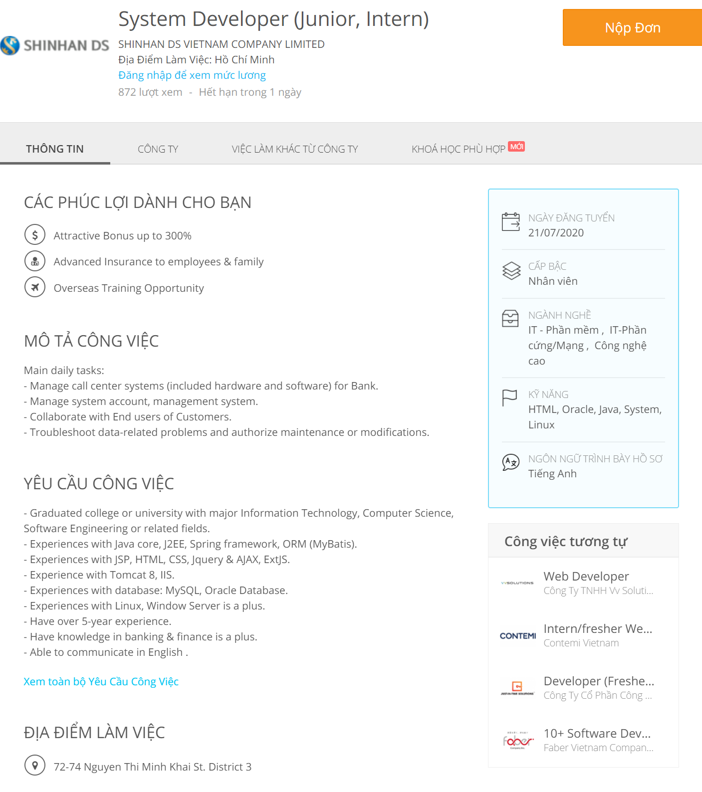

1. Ideal job: Web Developers (Link to the website)

2. Job's plan:

* JavaScript, HTML, CSS were learned within 7 years
* Participating in some web developing courses

If I want to apply for this job with necessary skills. For programming languages such as Java, Python, HTML, and CSS, I must learn this within 5 years. For operating systems like Linux or Window Server, besides learning at school, I will apply at some training courses. Finally, for the banking and finance skills, therefore I must study Management but still I must apply for some courses for 3 years as well.

***Quynh’s Ideal Job***

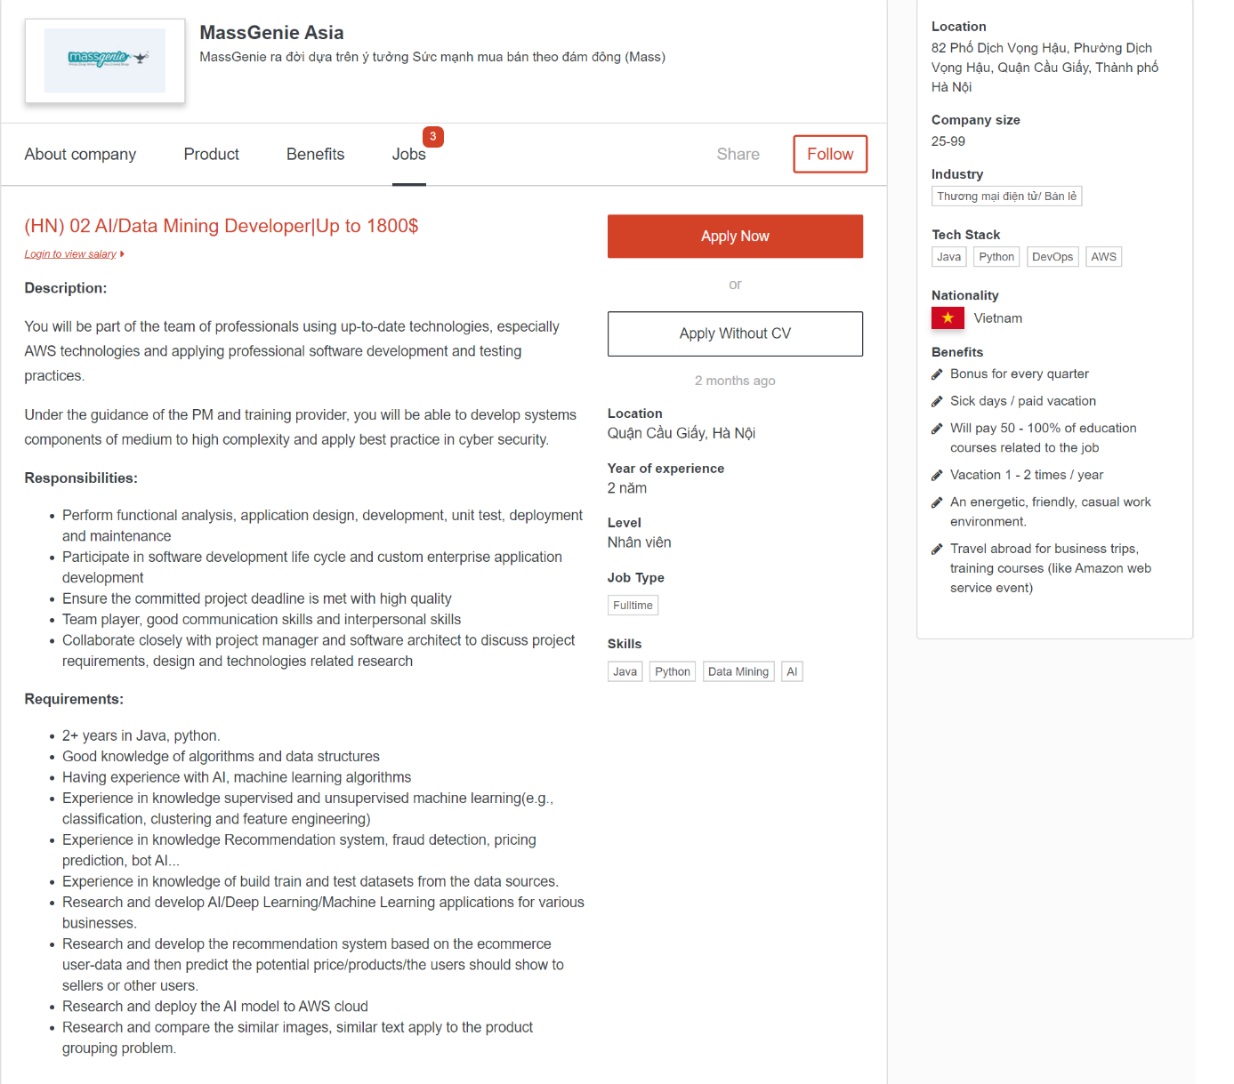

1. My ideal job: AI / Data mining developers (Link to the website)

2. Plan in the future:

* Having participated in an internship for an international company on second year and currently on hire when completing the internship session.
* Completely course AI, machine learning, AWS on Linked Learning
* Reading more book about algorithms and data structure (List of the book)
* Working project relevant to AI and machine learning (creating the face detect, AI chat bot, etc.)
* Have two reports or research papers relevant to AI, machine learning, deep learning.

***Ideal Jobs’ Analysis***

Based on the job description, our group’s ideal jobs focus on 3 different segments of IT - Database, Hardware/Software, and AI. Tuan’s ideal job - Database Administrator, in general, involves “designing, implementing, managing and maintaining company’s databases”. Anh’s ideal job - System Developer focuses on managing, maintaining, and troubleshooting company’s systems like accounts, call centers, and others. On the other hand, Quynh’s ideal job - AI/Data Mining Developer requires her to “perform functional analysis, application design, development, unit test, deployment and maintenance”. Despite the differences, our group believes that data is the common element between Tuan and Quynh’s jobs.

Data is involved heavily in both Tuan and Quynh’s jobs. As a Database Administrator, Tuan must work a lot with data since it is his job to keep the company’s database performing sufficiently to “ensure the availability and consistent performance of our corporate applications”. On the other hand, as an AI/Data Mining Developer, Quynh needs the data to perform her tasks as data is important for AI to train test units or models. In other words, Tuan keeps the database functional for Quynh, so she can use the data for her AI’s tasks.

On the other hand, one could say that Tuan and Anh’s jobs have a common background. Since both Tuan (Database Administrator) and Anh (System Developer) are required to maintain, improve and troubleshoot the system they are assigned to; they are, technically, doing the same job but in different segments of IT, with different focuses.

***Career Plans’ Analysis***

For Tuan, with his interest in Networking, Database, and Cyber Security, within the next 5 years, he plans to study on his own thoroughly most of the coding languages for those fields like C, C++, Java, Python, and so on. He also plans to intern at relevant companies to strengthen his skills and experiences. If possible, he also wants to get his Master’s degree right after he graduates from RMIT. After that, he would love to work for around 5 years with some self-study of general business/finance to prepare for the next big step. His biggest goal, at this moment, is to start up a cloud/server/database solution company with his best friend who is majoring in Finance and Logistics.

For Anh, he does not have a clear career plan for himself yet. At the moment, he wants to strengthen his coding skills with Java, Python, HTML, and CSS within the next 5 years. He also wants to study Linux and Windows Server. On the other hand, he plans to also study some business courses to improve his skills in finance.

Lastly, Quynh sets her goals to be an expert in the field of AI/Machine Learning. She plans to apply for an internship during her second year of internship to gain more experiences. She is also in the progress of self-study of AI, Machine Learning, and AWS on Linked Learning. She wants to gain enough knowledge and experiences to start researching furthermore on the topic of AI, Machine Learning, and Deep Learning with a focus on some topics like facial recognition/detection, AI chat bot, and so on.

To sum up the analysis for our group’s career plans, each of us has our own plans and paths for the future. At the present, since our group’s members are still in our first or second year in college, it is certain that we still have a lot to learn and experience to prepare for whatever we plan in the future, at least for the next 2 to 3 years. After this period, it is when the difference starts to kick in. For Anh, he is not sure about what he wants to do next, after his college life. For Tuan, he wants to start up a company with his friend that provides cloud/server/database solutions for others; while, on the other hand, Quynh wants to go deeper into the field of AI/Machine Learning.

***Tools***

**Website of each member:**

Thanh Tuan's website: [Link to the website](https://s3836455.github.io/S2-2020-Intro-to-IT-Group10-A2/)

Ky Anh's website: [Link to the website](https://s3812288.github.io/Assignment/index.html)

My Quynh's website: [Link to the website](https://myquynh.github.io/HtmlPage1)

**Website of the group:** [Link to the website](https://s3836455.github.io/S2-2020-Intro-to-IT-Group10-A2/index.html)

**Our group Git repository:** [Link to the Git repository](https://github.com/s3836455/S2-2020-Intro-to-IT-Group10-A2.git)

**Brief description on work:**

In the tutorial, we have learnt 2 ways push code on Github which is using collaboration or using fork ways. Our team decided to use collaboration ways. At first, our leader - Tuan created the repository for our group on Github and then invite other members to this repository so they can edit and pull the code.

At first, we did the code on our computer and then combined it to one file. Then, we chose one day which is the day near deadline to push the code together. Therefore, it would reduce the mistakes and errors during the process of pulling the code to Github. For CSS and images, Tuan, the leader, will push it to Github.

**Comment on the Github repository:**

* All team members have attributed and push their code to the Github well
* All the commit messages are written in great details so others member could know which part had been done and which part had not
* While looking at the history of the repository, the date we push all code was quite closed to each other because we planned to push our code in one day together to reduce errors and mistakes while pushing it to Github.

***Industry Data***

***Tuan’s insights in industry data***

My ideal job - Database Administrator ranks 30 in terms of demand from employers based on the Burning Class Data of March 2018.

**IT-specific skill set rankings in terms of demand from employers:**

* SQL: 1
* SQL Server: 13
* MySQL: 30
* Database Software: 183

**Generic skill set rankings in terms of demand from employers:**

* Communication Skills: 1
* Problem Solving: 2
* Organizational Skills: 3
* Writing: 4
* Teamwork / Collaboration: 5
* Troubleshooting: 6
* Planning: 7
* Mentoring: 13
* Analytical Skills: 17
* Team Building: 18
* Management: 19
* Multi-Tasking: 20
* English: 21

**Three highest-ranked IT-specific skills that are not in my required skill set:**

* JavaScript: 2
* JAVA: 3
* Microsoft Windows: 4 (I believe this one is required but not listed in the required skill on the job posting site)
* SAP: 5

**Three highest-ranked generic skills that are not in my required skill set:**

* Detail-Orientated: 8
* Creativity: 9
* Research: 10

After checking the Burning Glass Data, I realized that my ideal job is not in the top spots in terms of demand from employers. As my interest in IT varies between Database/Server, Networking, and Cyber Security, I can, in fact, choose a higher-ranking job like Network Engineer. I choose Database Administrator because I want to learn and improve my skill set in this field so I can prepare for my database/server solution startup in the future. So, the data from Burning Glass Data did not affect my choice now. However, it is good for me to keep it in mind so that I can predict the trend and prepare carefully for my startup.

***Anh’s insights in industry data***

1. **Jobs Title:** Web Developers, this job ranked in 15th places which is 381 demands

2. **Required skills:**

* **General skill:** communication skill (44367), problem-solving (16445), writing skill (15590), teamwork (14364), creativity (7475) - The first 3 skills ranked consecutively in range from 1st to 5th, except for creativity held at 9th places
* **IT specific skill:** JavaScript (2946), JAVA (2860), Microsoft Window (2699) - These IT specific skills ranked in range from 2 to 4, which means these skills are the most demanding skills from employers.
* **3 highest non-required IT specific skills in my skills set:** - SQL (3570), Project Management (2252), SAP (2189)
* **3 highest non-required generic skills in my skills set:** - Organization (15844), Planning (11315), Troubleshooting (11471)

Having looked at the Burning Glass Data, I have changed my mind. Instead of becoming a Web Developer, it would be possible for me to become a systems administrator which is 681 demands. The reason is systems administrators require teamwork to make the system more efficient and more secure.

***Quynh’s insights in industry data***

The job titles for my ideal jobs is Data Engineering and it ranked in 38 which had 187 job posting.

**General skill:** Problems solving, Teamwork, Troubleshooting

According to the Burning Glass data, the problem-solving skill at first thought it would be at the top of the list. However, it turned out in the second place with 16445 demand. Teamwork is on the fifth place with 14364 demand. Finally, the Troubleshooting is on the sixth place with 11471 demand

**IT specific skill:** SQL, Python, C++, Java, R, Tableau, PowerBI, AWS.

According to the Burning Glass data, Python is in 1150 demand. SQL is on the top of the list which is 3570 demand. C++ is 692 demand which quite surprised me because many systems like Facebook, Twitter still used this programming language and I thought the demand would be large. Java is in third place with 2860 demand. R is not included in the list since it is specialised used among statisticians and data miners. Tableau and PowerBI can be known as Data Visualization but they are not included in the list. AWS is in 211 demand.

**The three highest-ranked ​IT-specific skills​ which are not in my required skill set**

Except for Java (third place) and SQL (first place) which are already listed in my required skill, there are three highest-ranked IT- specific skills which are not in my list : Javascript (2946 demand), Microsoft Windows (2699) and Project Management (2252).

**The three highest-ranked ​general skills​ which are not in my required skill set**

There are highest ranked general skills which are not included in my list are Communication which is on first place with 44367 demand, Organization skill (15844) and Writing (15590).

According to Burning Glass data, although my job is not in great demand, I still insist on my ideal job because of these reasons. Firstly, if I work with Data, I can do anything within the fields from healthcare to business since data is everywhere and everything needs data. Secondly, the salary. Although this job is not great in demand, the salary ranges from $72,000 to $158,000 per year according to Glass Door. Finally, I have a huge passion for data so I will not change my mind and go with this job.

***IT Work***

[Link to the interview video with Professor Tran Ngoc Quang!](https://web.microsoftstream.com/video/8b892034-dfb3-4358-aa17-b8f1740be89a)

Mr. Tran Ngoc Quang is currently one of the IT professors at RMIT University Vietnam. He shared with us that he has been working in the field of education for the last 15 years, specifically in IT major classes. Although he works as an IT professor, it is hard to classify him as an IT professional. However, he also shared that he worked as Software Engineer for about 2 years in the US. The content of these question will only focus on the time when he worked as an IT professional.

**1. What kind of work is done by the IT professional?**

As a Software Engineer, his main job was to write software products. He said that the first step was to design the software. Then, he wrote the code, implement it, and do some simple test of the software. After that, the software got delivered to the tester for further testing. When the results came back, he would then check if there were any bugs or issues with the software and proceeded to fix them. He mentioned that he only did a small part of the main system and contributed them to the team.

**2. What kinds of people does the IT professional interact with? Are they other IT professionals? Clients? Investors? The general public?**

During his time as a Software Engineer, despite the stereotype about IT people that they only sit at their desks and work alone, he had to interact and communicate with a lot of people. Like many other Software Engineers, he did not finish the product on his own. There was a team of several people who worked together to finish the product. Besides communicating with other team members to plan and finish the project, he and his teammates had to follow the company’s guidelines to avoid confusions and errors. He also interacted with testers about the possible bugs and errors in the code. He shared with us that he did not communicate with the clients about the requirements and needs for the software, all this information was documented and delivered to him and his team through Product Managers and Business Analysts.

**3. Where do the IT professionals spend most of their time?**

Professor Tran Ngoc Quang shared that he spent 60 to 70 percent of his time designing and writing the code for the software. During the designing phase, he had to figure out the functions and features for the software, in other words, the requirements of the software and its uses. During the programming phase, he then proceeded to write his part, contribute it to the team’s work, and do some simple testing. He also shared that 80% of the people who work in the IT industry are good at coding and most of the IT jobs require some sort of programming and coding. So, it is safe to say that IT professionals, in general, spend most of their time designing and programming.

**4. What aspect of their position most challenging?**

For him, it was important to understand the functions and features he needed to deliver. Because, failing to do so resulted in bad programs, unused features, and time-wasting. However, he and his team did not communicate directly with the customers/clients. Product Managers and Business Analysts were responsible to document, deliver presentations and explain to his team about what his team needed to do. From there, he and his team could build the software. There were times that what the clients came up with was not efficient or fitted into the system, he had to discuss and suggest a better alternative to maximize the software to avoid bad programming.

**5. Can you give me 3 words to describe IT industry?**

Disruption: Changing the way that people live.

* The switch from selling airplane tickets at an office to selling them online disrupts the entire market as airplane ticket agencies become less and less a convenient option.
* Calling taxi has become somewhat obsolete with the development of online car booking like Uber or Grab.

Quality of life: Improving human life with the power of IT.

* Listening to music is now amazingly simple on the online music service with your mobile device, instead of carrying around your CDs.

Automation: “Things can be automated needs to be automated”.

* A good software from one person with the help of a machine can possibly do a job of a hundred people in the past.

***IT Technologies***

**Virtual Dispersive Networking – Cybersecurity**

***What is it? How does it work?***

Just like traditional Virtual Private Networking (VPN), Virtual Dispersive Networking (VDN) provides a more secure network with online anonymity and others features like bypassing geographical filter and so on. The biggest difference of VDN compared to VPN, in terms of security, is its ability to tackle the problem of the Man-in-the-Middle attack. According to Jason Bloomberg (Forbes), the core idea of VDN was based mainly on the technique of military radio communication called spread-spectrum security [1]. “By spreading the signal over a larger frequency band”, “this makes the signal more difficult to distinguish from noise and therefore more difficult to jam or intercept.” [2]. On the other hand, in terms of cyber security, when the VDN is deployed (for example, in an end-to-end network), the messages/packages from the sending device are split up into “several different simultaneous parts”. These parts are then encrypted and sent to the receiving device through multiple paths and nodes. When the encrypted parts reach its destination, they can only be decrypted and reassembled by the receiving device [1]. By splitting and spreading the message over multiple paths and nodes of the virtual network, this practice makes it harder for hackers, who utilize the Man-in-the-Middle attack, to gain useful data/information since the collected data is not only encrypted, but also just a small part of the actual message/package.

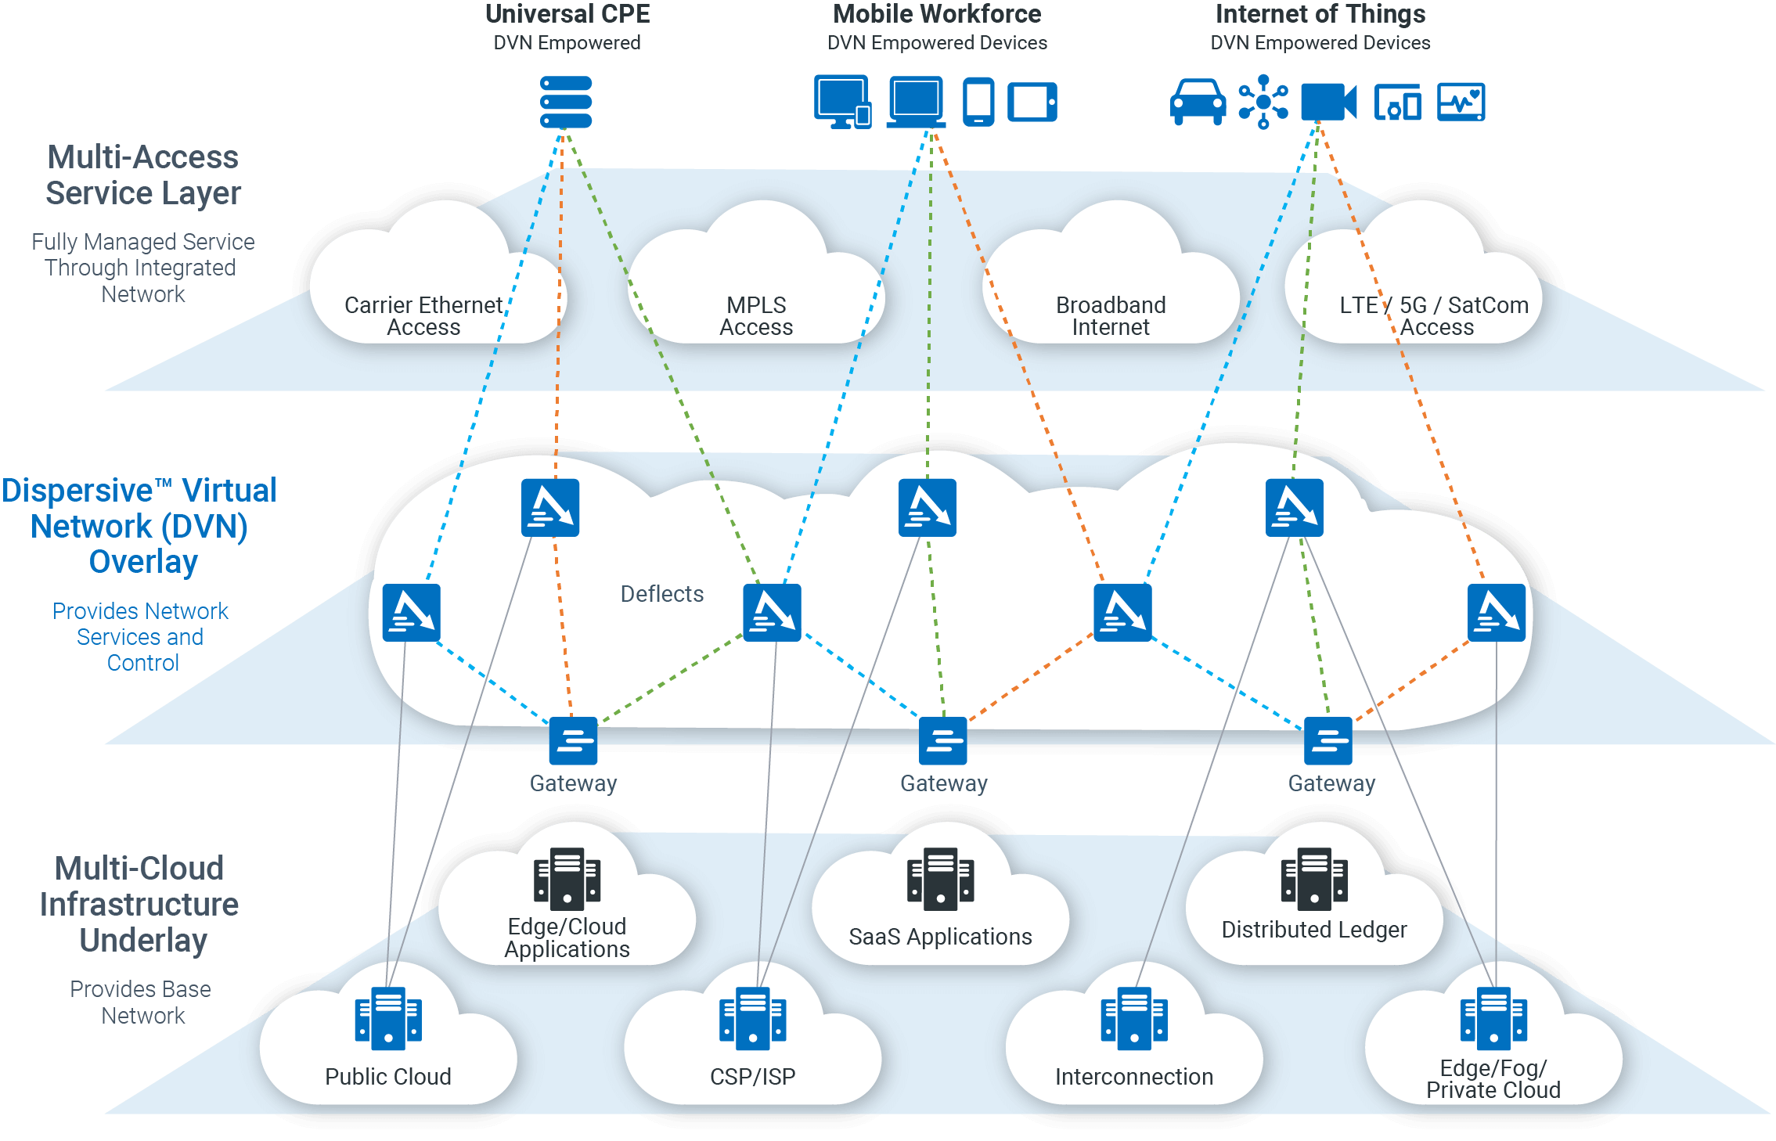

***What is the state of the art of this new technology? What can be done now?***

Virtual Dispersive Networking (VDN) is invented by Robert W. Twitchell, Jr. It is already patented and under the ownership of Dispersive Networks, Inc. Since there is no public research on improving VDN from both the inventor and the patent owner, but rather on its applications, it is safe to say that VDN is currently at its state-of-the-art form. Based on the website of Dispersive Networks, Inc., one of the main focuses of the company is its cyber security concept named SASE, which stands for Secure Access Service Edge. SASE, according to the company, is developed based on the convergence of Network-as-a-service and Security-as-a-service with the intention to unify and simplify the two services [3]. The VDN technology is used to power SASE as one of its key features, especially in terms of security. Other projects with VDN from Dispersive Networks, Inc., that are worth mentioning, are the partnership with ClearBlade to “accelerate and secure IoT edge and cloud deployments” in July, 2020 [4] and the partnership with Envistacom to improve and enhance the U.S. government and military networks’ security in February 2020 [5].

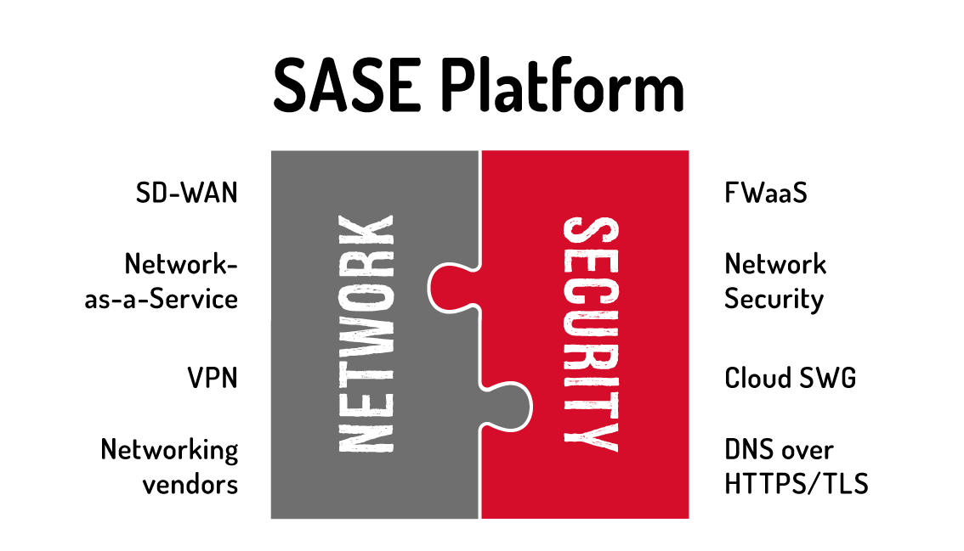

***What is likely to be done in the next 3 years?***

Rick Conklin (Chief Technology Officer of Dispersive Networks, Inc.) and Ben Murray (Founder and CEO of Pulse Lab) and the Silicon Valley Blockchain Society have partnered up and released a white paper named Securing Enterprise Blockchain with SDN in 2019. The main idea of this white paper focuses on the benefits when combining blockchain (“decentralized data management and integrity capabilities”) and virtual networks like VDN (“highly secure, resilient, and fast”), and how they can actually be fused together [6]. Following up with this white paper, ClearBlade also joined this partnership and the four companies have established a project called Blockchain Network Fusion. With the rise of blockchain adoption in the last few years and the partnership of these four global leaders, it is safe to say that the combination of Blockchain and VDN will transform how data and data sharing works in the near future [7].

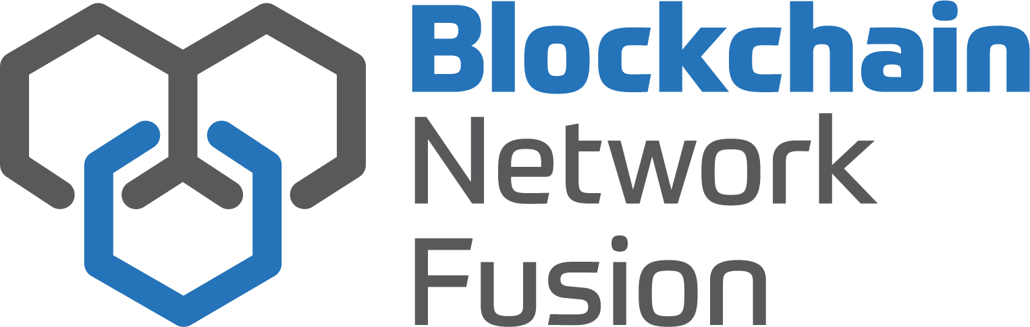

***What technological or other developments make this possible?***

As mentioned in the first question, the key idea behind VDN is mainly based on the technique of military radio communication called spread-spectrum security. Just like spreading the signal over a larger frequency band in spread-spectrum security, VDN splits the message, encrypts it, and sends these pieces over multiple paths and nodes of its virtual networks. The receiving end will decrypt and unify these pieces to reform the message. Another technology, that is worth mentioning, is Virtual Private Networking (VPN). In my opinion, VDN is, technically, an improved version of VPN. The main difference between the two networking methods is how their data is being transferred in the virtual networks, single-path (VPN) vs multi-path (VDN).

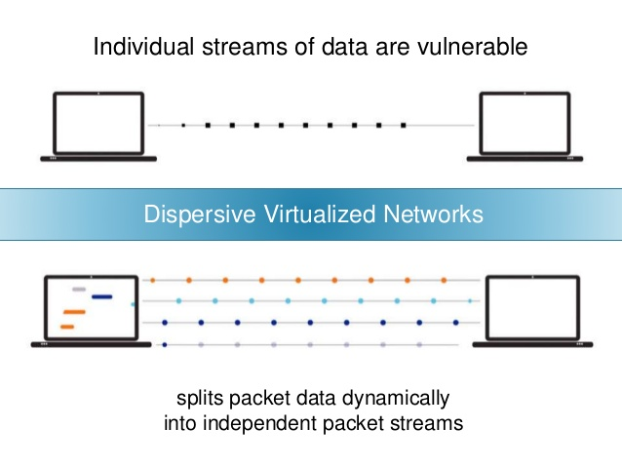

***What are the likely impacts? What is the potential impact of this development? What is likely to change?***

Since the VDN technology is still new and without actual deployment for us to analyze, compare, and contrast its actual efficiencies in the field, let us assume that the VDN works perfectly as advertised. In my opinion, there is at least one potential impact of this development. The speed of data transfer and how it works will be significantly improved. According to Dispersive Networks, Inc., as the data is split up and sent across different routes (multi-path) with the ability to switch to “a new unimpeded path” if there is an occurrence of congestions or attacks, this helps increasing the speed of our data transfer and assuring the delivery of the data to its destination [8]. With the development of VDN, transferring a large amount of data (for example, Big Data) over the Internet can now be much faster [1].

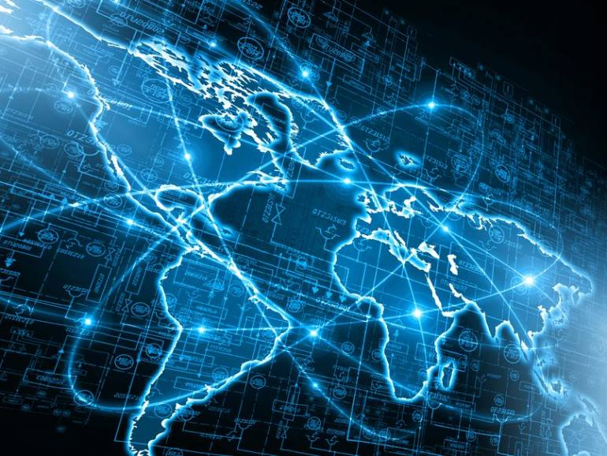

***Which people will be most affected and how? Will this create, replace, or make redundant any current jobs or technologies?***

There is no doubt that hackers, especially who utilizes the man-in-the-middle attacks, are one of those affect by the development of VDN. But, if we dig a bit deeper into it, VDN can make VPN redundant in the future. As I mentioned in the first section, VDN can, somewhat, be understood as an improved version of VPN with better speed and security features. According to a demonstration video from Dispersive Networks, Inc., VDN provides a faster, more reliable, and stable connectivity when compared to the traditional VPN [8]. However, one could make an argument that VDN cannot make VPN become obsolete anytime soon. According to Jason Bloomberg (Forbes), the scope VDN technology focuses mainly on the improvement of government/military networks or big companies like banks, rather than VPN providers or end-users [1]. But, in my opinion, there is still a good chance that VPN will be slowly replaced by the newer and better VDN technology if it becomes mainstreamed and commercialized for end-users.

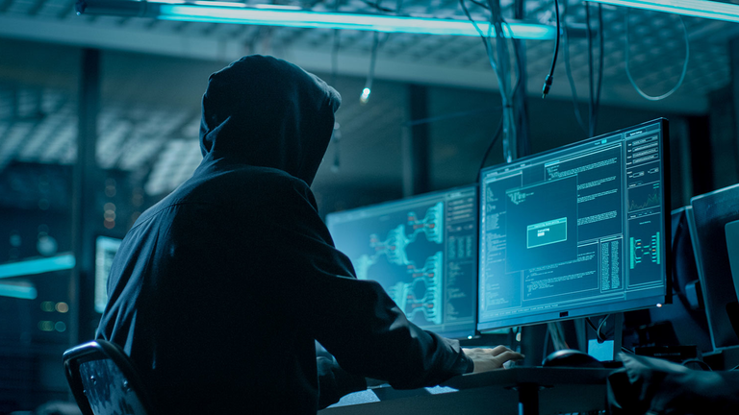

***In your daily life, how will this affect you? What will be different for you?***

At the current state of the VDN technology, I believe that it has no obvious effect on my daily life. Since the focus of Dispersive Networks, Inc., the company which owns the VDN technology, is towards government, military, and big companies, there will not be any direct effects on normal citizens like me. However, let me imagine that VDN had become more recognizable and adopted by many current VPN providers. As a person who has friends around the world, I often spend my free time playing online video games with them. However, due to the latency of the connection from my computer to the game servers in other places like US, the game is almost unplayable, and it is hard for me to enjoy the game to the fullest. With the assistance of VPN, the connection improves a little bit but still not enough. But, with the new VDN technology, it might be a completely different story as the data is transferred in pieces through multi paths and routes to compensate for the latency of a single-path connection.

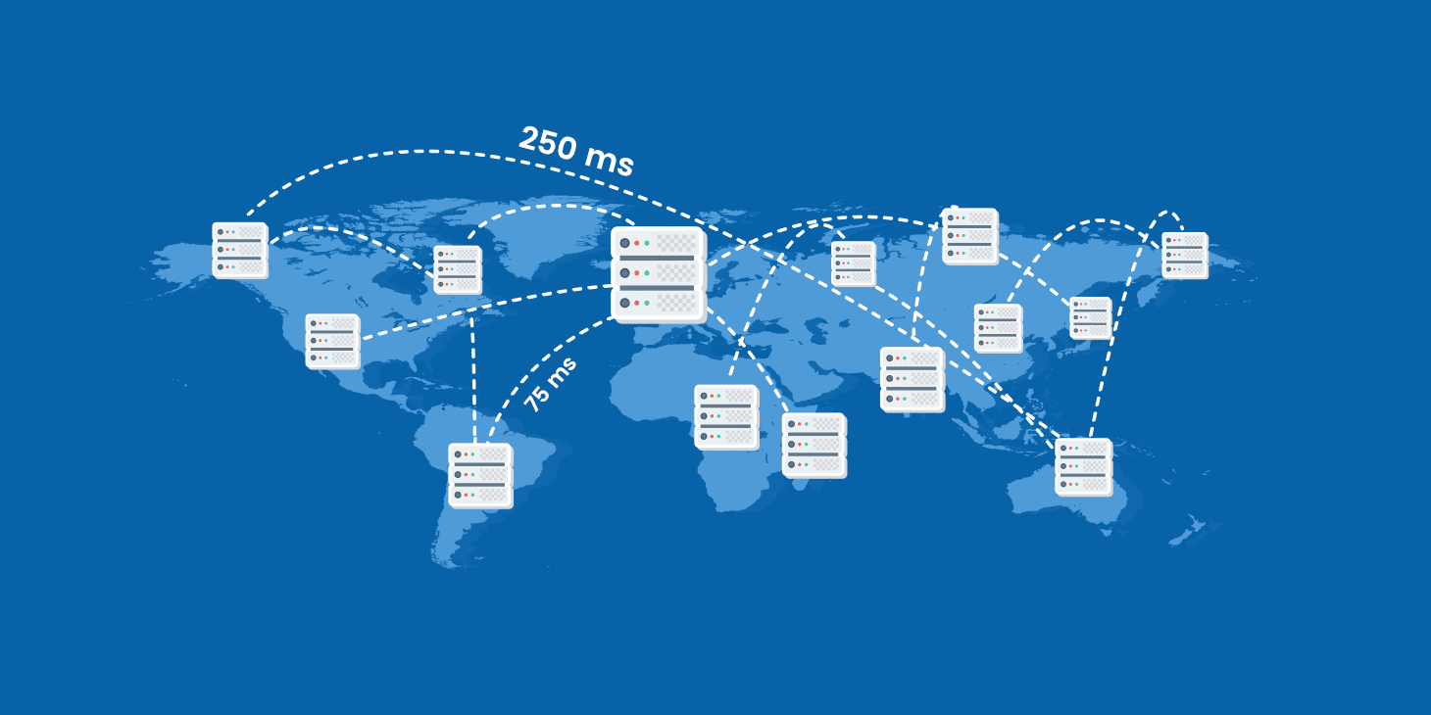

***How might this affect members of your family or your friends?***

Since Quynh, a member of our TAQ Team, has a huge interest in Machine Learning and AI, the ability to have fast and reliable accesses to data is extremely important to her. With the development of VDN, it provides a huge advantage to the field of Machine Learning and AI as data across different database, servers and locations can be accessed much faster with better security features. Another friend of mine, named Raquel, works as an IT specialist for Washington State Department of Ecology. Her job is to manage the administration system and the database of the State Department. We had a little talk about VDN, and she said that if this technology performed as intended, it would be a great addition to the current system at her company. However, legacy systems can be a big problem when deploying VDN into the real world since the switch can be extremely expensive. Regardless of that, it is a promising development to consider.



**Blockchain and Cryptocurrency**

**About Blockchain**

***What does it do?***

The term ‘Blockchain’ - [1] “is a decentralized transaction and data management technology developed first for Bitcoin cryptocurrency. The interest in Blockchain technology has been increasing since the idea was coined in 2008. The reason for the interest in Blockchain is its central attributes that provide security, anonymity and data integrity without any third party organization in control of the transactions, and therefore it creates interesting research areas, especially from the perspective of technical challenges and limitations”. Therefore, currency transactions are often controlled and centralized by third party organizations. Thus, currency transfers and digital payments require intermediaries such as banks or credit cards to make transactions. Additionally, a fee is caused when making a transaction from these intermediaries. This process also applied in some domains namely Games, Music, Software and more. Rather than allowing two principal entities whose making transaction to control their data and information, in fact this was in charge by the third party. To solve this issue, blockchain technology has been developed. The purpose of blockchain technology is creating a decentralized environment where there are no third parties involved.

Therefore, the application of blockchain technology has been applied in many fields, especially for those that have historically relied on third parties. The state of art of blockchain technology is EOS, a new blockchain protocol. According to EOS creator Dan Larimer, the purpose of this new development is to provide a secure and transparent system. Furthermore, EOS also offers a management system for both local and global monetary transactions. Moreover, EOS is a decentralized platform, its main purpose is to develop and support the ability to build decentralized applications.

***What can be done now?***

At the moment, blockchain technology was only used for financial and non-financial purposes. Applications of blockchain were divided into two sections - financial and non-financial. I will list down some applications for each section:

For financial applications:

- Cryptocurrencies: digital currency using cryptography to manage and secure transactions. By using blockchain technology, cryptocurrency cannot be copy and hacked, the owner can avoid these properties being stolen.

* For example: Bitcoin, Litecoin, EOS.IO, ...

- Insurance: such as insurers properties might be registered by using blockchain technology, the insurers then can check the transaction history.

* For example: Everledger, ...

For non-financial applications:

- Music industry: determining music royalties and managing music rights ownership.

* For example: Imogen Heap, a British singer sells her songs using the blockchain

- Decentralized proof of documents existence: storing and validating the timestamp and signature of a document using blockchain.

* For examples: www.proofofexistence.com website's purpose is to store your documents. POEX.IO or Proof of Existence provides anonymity, privacy and decentralized proof which allow your uploaded documents cannot be erased or modified by anyone, even the third parties. You can publicly upload your documents online, but other people cannot copy your works or change the owner's name or the published time.

- Decentralized storage: sharing documents without third parties to involve by using peer-to-peer distributed cloud storage platform.

* For example: Storj.com, Storj is an end-to-end cloud storage platform which uses cryptography to secure your files. Additionally, your files are then encrypted, break into ‘pieces’ and then stored in decentralized networks and servers which only you can have access to your files. Therefore, Storj provides you a token which is similar to cryptocurrency, the main function of this token is you can use the token to buy more storage. Furthermore, people who lack storage can rent you at the cost of this token.

***What will be done in the future?***

Although there were just a few areas that apply blockchain technology, in the future there will be an expansion on using blockchain technology. I will list down some area that might and will be using blockchain technology in their applications:

* Using blockchain technology for healthcare purposes:

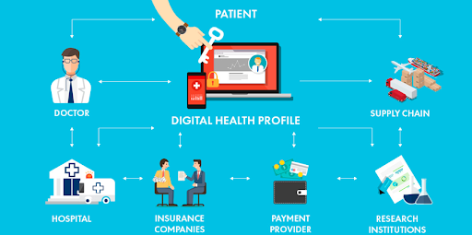

Blockchain technology is considered as a virtually incorruptible database. Therefore, using blockchain technology could reduce the medical costs, secure the information about critical health issues in the world, secure the patients data and medical sensitive data. Additionally, blockchain is treated as a distributed ledger to store healthcare or related data for exchanging, sharing, analyzing, recording, and validating among stakeholders [2]. Furthermore, beside healthcare applications, the Health Information Exchange or healthcare transactions between patients, providers, and other relevant parties is also the most discussed. These recorded data are described in the Improved medical record management, Enhanced insurance claim process, and Accelerated clinical/biomedical research sections.[3]

* Intelligent vehicles:

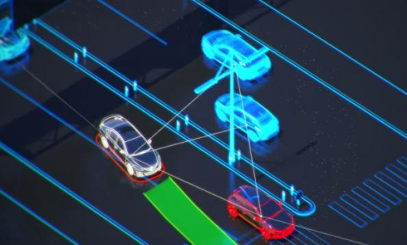

Intelligent Vehicles (IV) or simply known as self-driving transportations. These transportation use ad-hoc networks for vehicle communication which namely Dedicated Short Range Communication (DSRC), Wireless Access Vehicular Environment (WACE), and cellular network. Therefore, these ad-hoc networks do not guarantee a secure data transmission.[3] In fact, the Intelligent Transportation System (ITS) is based on cellular and IT standards mechanisms, which therefore are not up-to-date and can be harmful for the system.

In the future, these IVs will be fully autonomous, by using dynamic blockchain (LDB) and main blockchain, enabled with a secure and unique crypto ID called intelligent vehicle trust point (IVTP). The IVTP provides trustworthiness among vehicles. Vehicles then use and verify the IVTP with the LDB to communicate with other vehicles.[4]

* Logistics

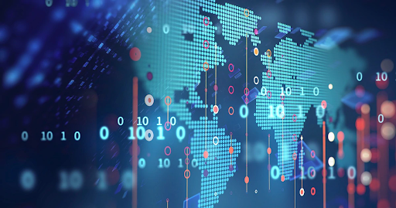

The supply chain is a complex process of distribution and creation of goods. Depending on the types of the product, the supply chain can contain many phases, multiple geographical locations, several individuals, entities, accounts, and payments, and means of transport. By applying blockchain technology in the supply chain processes could improve its sustainability. Blockchain can enhance the efficiency and transparency of the supply chain and affects all supply processes, delivery, and payments. In addition, tracking goods through blockchain can improve the decision-making process with the result being a more satisfying service for the end user.[5]

***What is the likely impact?***

Blockchain technology nowadays has been used more frequently by many companies and areas. The most potential impact of blockchain is data storage and management. Therefore, the original recorded data were publicly online so people can read, observe, and even change it. When the recorded data has been changed through several processes, it becomes unreliable. Some data even was stolen and re-edited with a different owner. By using blockchain technology, the data then is decentralized and secure. The owner can stamp their published date and name on a block in a blockchains, in addition, the data when uploaded to a block are being decentralized and cannot be changed or copied. Therefore, the most affected people are the stakeholders, companies, or any organizations because it will change the way they are used to store and protect the data. This development will not replace, create or make redundant any of the current jobs. The only thing that will change is the technologies used to store the data and software that provides protection to these data.

***How will this affect you?***

In the future, this development will be an efficient way for me, my family, and friends to protect my data, which prevents plagiarism, avoiding my data being stolen and changed. Especially when doing a project, by integrating my name, establishing a date, project information on the blockchain, I will avoid others copied my works and make it become theirs. This development also affects the way we stored data, instead of saving them in the folders on a laptop or PC, we can upload them in a block on chains of blocks, by decentralizing our data, our works cannot be hacked. Seeing our data being secured, the less nervous we are.

**About Cryptocurrency**

Cryptocurrency is a type of currency that has been encrypted with a function similar to physical money, but it instead exists in digital form. Unlike physical money, which is used in real life, cryptocurrency is usually used for transferring purposes, bought or sold items between parties over the Internet and its values were determined by the market. Cryptocurrency also can be used to purchase products or services, along with making payments to other things on the Internet. The current state of the art of cryptocurrency is EOS.IO, a modern cryptocurrency which was introduced in 2017.

***What does it do?***



At the present, the only application of cryptocurrency is for financial purposes such as mediums of exchange. For mediums of exchange purposes: some cryptocurrencies such as EOS.IO, Etherium or Bitcoin were used for purchasing and paying for commodities. Unlike physical money whose value can be copied by using unauthentic materials, cryptocurrencies use blockchain technology to decentralize, the monetary value then be encrypted. By using decentralized technology, the recorded transactions between two principle entities then being secured, cryptocurrencies therefore cannot be hacked or copied. When making a purchase, the tokens or coins that need to buy the items will be valued by the market.

***What can be done now?***

At the present, the only application of cryptocurrency is for financial purposes such as mediums of exchange. For mediums of exchange purposes: some cryptocurrencies such as EOS.IO, Etherium or Bitcoin were used for purchasing and paying for commodities. Unlike physical money whose value can be copied by using unauthentic materials, cryptocurrencies use blockchain technology to decentralize, the monetary value then be encrypted. By using decentralized technology, the recorded transactions between two principle entities then being secured, cryptocurrencies therefore cannot be hacked or copied. When making a purchase, the tokens or coins that need to buy the items will be valued by the market.

***What will be done in the future?***

In the future, the application of cryptocurrency will expand continuously not only for exchanging commodities but beyond that. I will down some possibility:

* Biomedical/Healthcare:

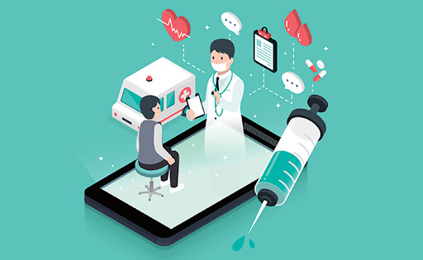

Therefore, in the future, healthcare will be using blockchain technology to store and secure data. Being decentralized, cryptocurrency can then be applied in medical areas such as for paying medical bills and medicines. The recorded transactions, and personal information like medical form can only be seen by the customers.

* Alternate currency system:



In the future, cryptocurrencies will replace the currencies system in the world. Creating a new virtual monetary credit which is decentralized and secure. This results on the impact of cryptocurrency to the world.

***What is the likely impact?***

With a stable development, cryptocurrency would be a revolution in economics all over the world, as well as the marketplace. The result of this is because cryptocurrency is a type of currency made from immaterial from the digital world which has been encrypted by blockchain technology. As we have known, every country has their own currencies, and if another type of currency exists in their systems, there will be an economic crisis. So that is why economics is the most potential impact of cryptocurrency. Therefore, if we want to avoid an economic crisis, the new cryptocurrency must be acknowledged worldwide and be used for exchange purposes. Besides potential impact, cryptocurrency can replace the term “Type of currency”. If a cryptocurrency like Bitcoin was used widely by all society, there will be a high chance that the current currency will be replaced completely, making it become the only currency that exists. With the rise of cryptocurrency, the type of person that easily gets attracted to this digital money is investors, especially young investors, or middle age. Unlike senior one, these two types usually seek for potential things that are worth investing in and cryptocurrency is one of them. The developing stage of cryptocurrency is significantly high, the money you get compared to the first time you invest in will be doubled or sometimes tripled if that cryptocurrency is successful in attracting people. For example, 1 Bitcoin now worth 266,509,023 VND. With that huge amount of money, no investor could resist it, especially for young people who are seeking for success. Furthermore, if cryptocurrency such as Bitcoin become a new currency unit in the world, the first thing will be replaced and wiped out is money-printing machine, and materials such as polymer and wood would no longer be needed for printing out the currency. With the extinction of the money-printing machine, therefore the person who is in charge of this machine will also be fired. Instead, people who have graduated Computer Science and received it qualification will be recruited, because cryptocurrency like Bitcoin cannot be achieved freely but instead you have to solve encrypted puzzles provided by Bitcoin software in order to achieve those coins. This process needs a lot of electricity and technical expertise.

***How will this affect you?***

Although cryptocurrency is developing constantly, there are still no crucial impacts of this digital money on our daily life now. This result in many countries is still underdeveloped, and many of them have not got access to the term ‘Cryptocurrency’ yet. For my daily life, physical currency is still the typical currency which is used day by day, people still use physical currency to exchange, sell and buy things and as time goes by, it has become a part of our life, the most thing we get used to. But in the future, things might go different as cryptocurrency would replace the entire currency system. Therefore, we usually bring with us a wallet and phone, but in the future the only thing you brought with us is just your phone or a crypto card for payments purposes. There will be no longer thieves that stole your belongings and if they do, they must encrypt your card to use your money, but that for the future. Furthermore, I do not need to go to the supermarket, mega mall or grocery stores to buy things, instead what I need is to lay back on the couch and press a button, all the items will be paid and ready to deliver. Life would be more modern, easier, and simpler for me. For young people like myself and my friends, it would be less difficult for us to get familiar with the term ‘cryptocurrency’, though we might see each other often and discuss it together, but for the elders and my parents it will be more difficult from knowing “what is it ?” to “how to use it efficiently”. Moreover, because they have been using physical currency for a long time, it will take time to explain for them and sometimes a family member will not know how to use electric devices as well.

**Machine Learning**

***What does it do?***

According to the definition of Expert System website, machine learning is a small area of computer science and it is able to learn things based on the given data without programming detailed instruction. The machine starts by testing something smaller and using statistical algorithms to see how the data fits together. It will test the outcome and see if it is correct by comparing it to the training data. Every time the machine learns something new, the data will be stored in the database. Therefore, it will improve and adapt [1].

It is hard to know which is the state of art of machine learning since each algorithm has its role in solving the problems. Therefore, I will list some well performing algorithms and how can we use it:

- Naive Bayes:

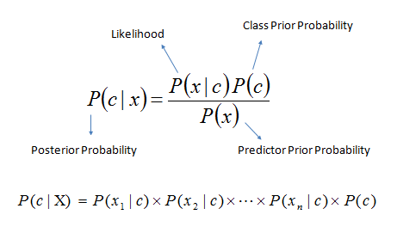

* According to Wikipedia, Naive Bayes is an algorithm that is commonly used in machine learning based on Bayes’s theorem. It is used to achieve higher accuracy prediction depending on the training data. The strength of using Naive Bayes is that it only needs a small number of training data to evaluate important parament for classification [2].
* Naive Bayes can be used in real time prediction, multi class prediction, text classification/ spam filtering/ sentiment analysis, recommendation system, etc.

- Decision tree:

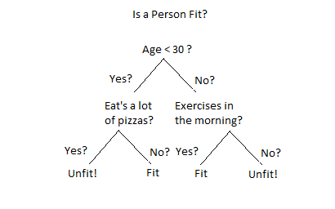

* According to Wikipedia, Decision Tree is a supervised machine learning which has a tree-looking flowchart structure and contains conditional statements (if, else if, else). Moreover, it can be used in both classification (more common) and regression.[3]
* Decision Tree has been applied in Banking Finance to classify customers into 3 types: good, average, bad based on their credit record.

- Random forest:

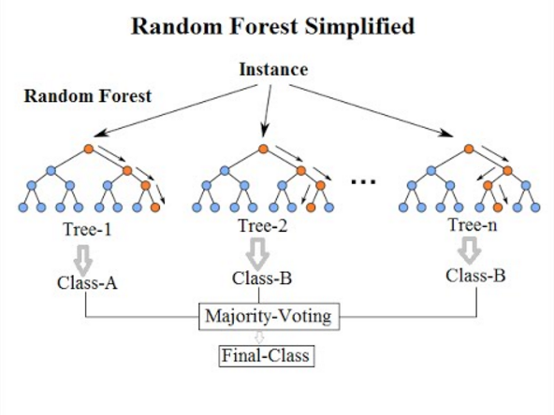

* Random forest and decision tree have the same concept, but it is slightly different. If a decision tree is built on an entire dataset, using all the features/variables of interest. A random forest, in the other hand, randomly selects observations/rows and specific features/variables to build multiple decision trees from and then averages the results.
* According to Wikipedia, Random forest contains many decision trees and combines them together to get a more accurate and stable prediction.[4]

- Ada Boots:

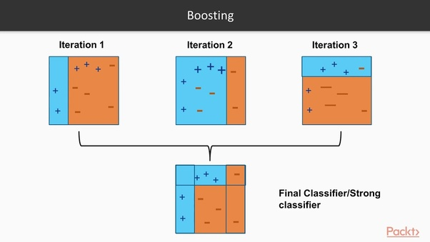

* According to Wikipedia, AdaBoost is used as a boost algorithm developed for binary classification. It makes the short decision tree have good performance by accounting for the incorrectly classified examples in the training set [5].

- Support Vector Machine:

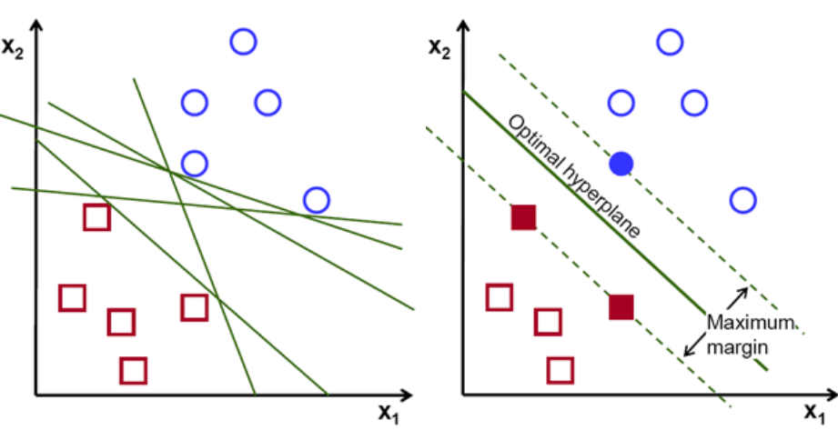

* According to Wikipedia, generally, the support vector machine is to find the best hyperland that is given the maximum margin from both tags. Therefore, this can be called as Maximum Margin Classifier [6].
* SVM has been used in real life applications such as Text Classification, Face detection, Handwriting recognition, Image classification, etc.

There are so many things that can be done with machine learning now:

1. Face, Image, Voice, Text recognition

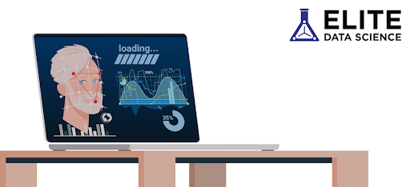

1. Improve Cybersecurity (use algorithms to detect injection attacks such as SQLi, XSS, Code injection, fraud, Malware, Money Laundering, Web Traffic analysis, Cybercrimes)

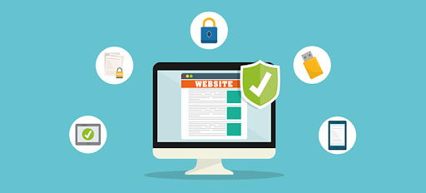

1. Better customer service (Chabot, Virtual Assistant, Content creator, IVRs)

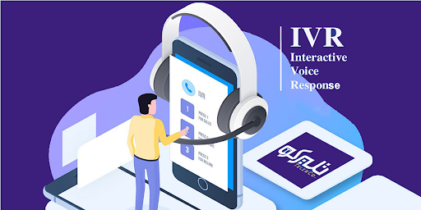

1. Better Healthcare (Robotic Surgery, Identify disease and diagnose, drug discover, etc.)

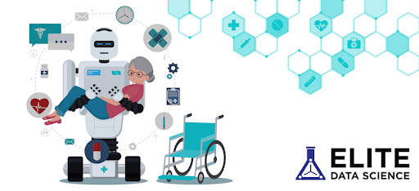

1. Automatic transportation and self-driving car (Machine Learning algorithms learn about surroundings and drive appropriately)

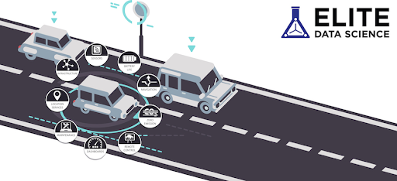

And in the next 10 years here is some research that likely to be done:

1. Predicting disaster

According to “Seismicity analysis and machine learning models for short-term low magnitude seismic activity predictions in Cyprus”, there are 3 techniques which are Random Forest, Support Vector Machine and Artificial Neural Networks. They are used for training to develop the data model to predict future earthquake (W. Li, N. Narvekar, N. Nakshatra, N. Raut, B. Sirkeci and J. Gao 2018)

1. Security in home

Face detection with the family members of the owner and alert if there are strange people from the training data. According to Wikipedia, the algorithms have been applied in this method are eigenfaces, linear discriminant analysis, elastic bunch graph matching using the Fisherface algorithm, the hidden Markov model, the multilinear subspace learning using tensor representation, and the neuronal motivated dynamic link matching.[19]

Sound analysis to know if there is a window breaking, footstep from the outsiders. The algorithms applied in this is Neural Network [8] according to “Deep Neural Networks for Acoustic Modeling in Speech Recognition: The Shared Views of Four Research Groups”

1. Improving higher level of Quantum Computing

According to Scarlett Rose in the written article “What is the Future of Machine Learning?”, by applying the quantum machine learning algorithms, the quantum computer will make the process of data go faster. As a result of it, this can help to extend the analysis’s ability and give a clear understanding from data sets. This invention will help the business gain more positive outcome than the normal machine learning techniques [18].

The potential impact of machine learning on 4 different area:

1. Business:

- Marketing Automation : According to "3 Ways to Automate Marketing with Machine Learning" by TopBots, machine learning will be used to identify target customers and help the company have the insight view which customers will be impacted on which methods : email, Facebook ads, etc. As a result of that, they will deliver a more specific user experience. There are many techniques that can be applied in this field such as one to one matching, prediction model, a/b testing, multi arm bandit, etc[11]. Although this method is not applied much in the business, it will be a necessary tool for those who work in marketing since it will boost their productivity by those methods I have shown.

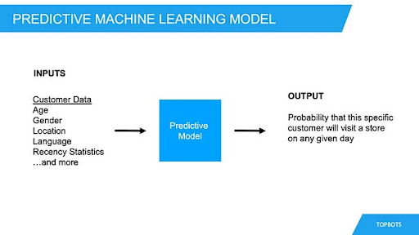

- Recruitment: The company called Textio has applied machine learning in job’s advertisements to analyze the pattern of language to attract more candidates. Another way that machine learning has changed this field is that CV- Screening. In one day, the company can receive more than 100 resumes and CV. This will be time consuming for the HR to read an amount of CV like that. Therefore, according to Ideal, there are 3 tools that apply machine learning to help the headhunters save time by finding the keywords, traits and qualities written in their CV that are necessary for the job based on the given requirement[12].

1. Healthcare:

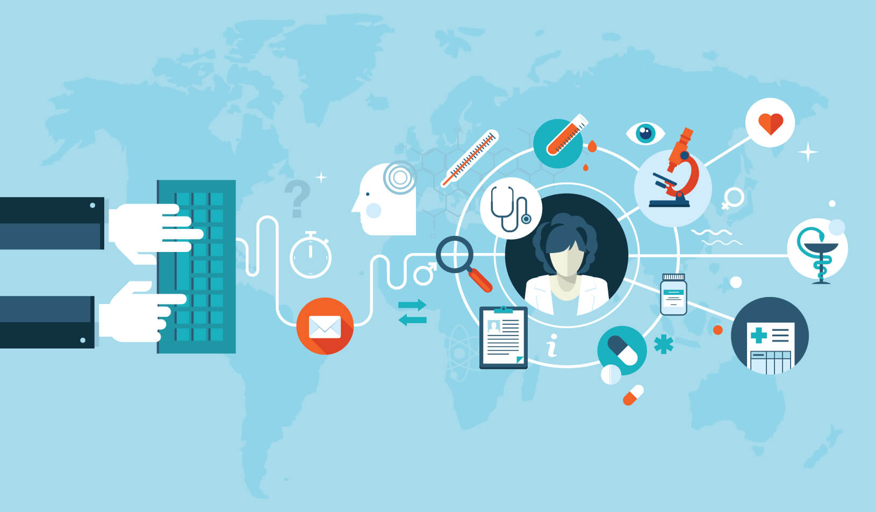

- According to “The Potential Impact of Machine Learning in Healthcare” by rx4Group, machine learning can make the diagnosis be quicker, more reliable and more accessible by using deep learning and image recognition [13]. An example of this can be the approach that uses machine learning, analysis prediction and pattern recognition to obtain accuracy for 89 percent, more than doctor which is 73 percent in diagnosing breast cancer according to “Google computers trained to detect breast cancer” by the Mercury News[10]. This kind of tool will mostly affect those who work in the hospital and the patient. For the doctors' side, this tool can help them to increase the accuracy in diagnosing the illness by the techniques I have shown below. For the patient's side, according to “How America’s 5 Top Hospitals are Using Machine Learning Today” by Kumba Sennaar, machine learning can predict the patient's condition to prevent the emergency situation from occurring. Moreover, by using real time data collecting, it also tracks the patient's health status [15].

1. Logistics:

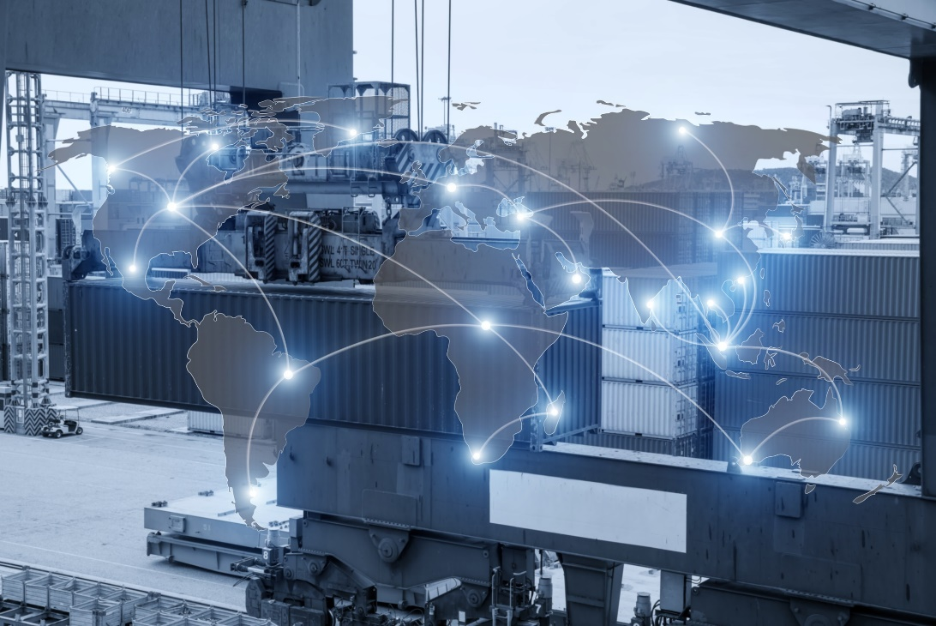

- According to “How Machine Learning Impacts Manufacturing and Logistics” by Nick Ostdick, machine learning will help companies produce higher quality products with longer life spans. It can pinpoint potential faults, failures, or defects during development in real time. State tracking also allows planners and administrators to have forecasting accuracy. It helps reduce the freight cost during the process [17].

1. Transportation:

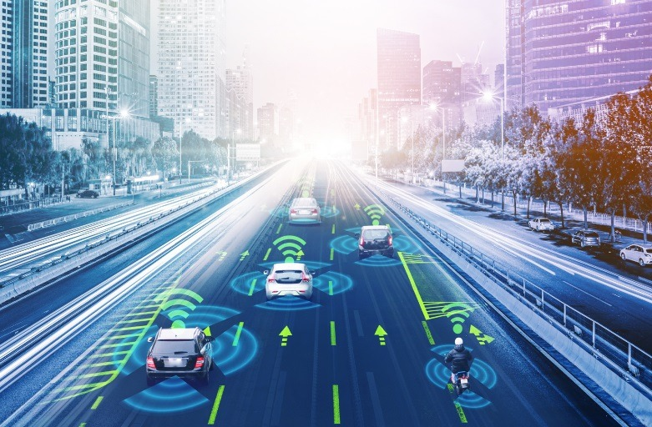

- Although the technology in self-driving cars is still not perfect, it still has the potential impact in the future. According to “15 ways Machine learning will impact your daily life” by Elite Data Science, the uses of machine learning help the car to continuously change the road condition, while learning a new road situation at the same time. Therefore, the decisions made will be faster than the well-trained driver. Self-driving car will make the road safer and prevent injuries [16]. Moreover, this can boost our productivity by searching for the fastest way to go to the destination or helping us to find the parking car easier [16]. As a result of it, it will cut down our fuel consumption which will save us a lot of money. The most people who will be affected by this technology could be drivers. Customers cannot put their trust on the whom they just meet at the moment since many crimes have occurred on this vehicle. Therefore, if the self-driving is legally permitted to ride on the road, they may switch to use it and the numbers of drivers will be cut down which leads to unemployment.

As a result of what I have shown, machine learning is a tool to revolutionize industrial technology since it makes all the works more efficient, more accurate and more accessible. Although machine learning is efficient and creates the bigger change in the manufacture, it will not replace an entire career. Machine learning just can do some of the tasks required in a job. According to “What machine learning can do and cannot do ?” by Irving Wladawsky-Berger, just some of the tasks in the occupation are suitable for using machine learning, while others require social skills, judgement and other human capabilities[14].

***How will this affect you?***

In my daily life, machine learning has a huge impact on me. Firstly, virtual personal assistant which is applied speech recognition, converting text to speech or speech to text and Natural Language Processing is a must-have tool in your life since it helps me, my family and my friends reduce the time of doing tasks and it also is a great help for someone who is lack of capability such as illiteracy or disability. My dad frequently calls his co-workers when he drives the car which is not safe if he was driving the car at the same time as picking up the phone. Therefore, with the great help of Siri, he just has to say “Hey Siri, call Tom” and the virtual assistant then looks in the contact data and makes the phone call. Another example is my grandmother, because of her ability, it is very difficult for her to use the phone to call somebody. However, with the slice of speech, she now can easily call my family without taking time to find where the phone icon is. Secondly, Google Translate, this application is applied to machine learning techniques such as Natural Language Process, POS Tagging, Chunking and NER and nobody can deny the greatest benefits that it brings to us. I use Google Translate as it is my daily routine, from translating it to read books to learning how to pronounce the word. This helps me a lot since it is not time consuming and it is free. Back in the days I did not discover this great tool, I bought a dictionary which just contained one language and it did not support the pronunciation. Moreover, when I want to look up the word, I have to search it in the alphabet order which takes me a lot of time to do so. However, compared to Google Translate, I can learn whatever language I want to, learn how to speak easily and search words very fast. My family uses mainly this for work such as translating the contract and speaking to foreigners. Overall, there are more applications using machine learning that affect us in different aspects.

In the future, with the help of machine learning in self-driving cars, I do not have to remember which ways to go to my wanted destination. Instead of that, I just have to enter the location I want to go and sleep until it reaches the destination. Moreover, it will help my father a lot since he has to work anywhere, anytime especially on the car. He has to make contact with his co-worker while driving the car which is not safe. However, with the help of self - driving cars, my father can work in the car and also guarantee safety.

**Robots**

According to ScienceTrek, the word ‘Robot’ comes from the Czech word ‘Robota’ which means ‘forced work or labor’. The word ‘Robot’ that humans use today is to describe a man-made machine that can perform human action or work, either automatically or by remote control. Therefore, the word ‘Robotics’ means the science and study of robots.

***What does it do?***

The state of art of this new technology is humanoid robots. According to Wikipedia, a humanoid robot is a robot having the body shape that looks like a human body. The purpose of using this robot is to interact with human tools or environment, explore space, be a personal assistant, search, rescue people,etc. The most advanced humanoid robot to mention might be Sophia - the first artificial intelligent robots that was developed by Hanson Robotics.

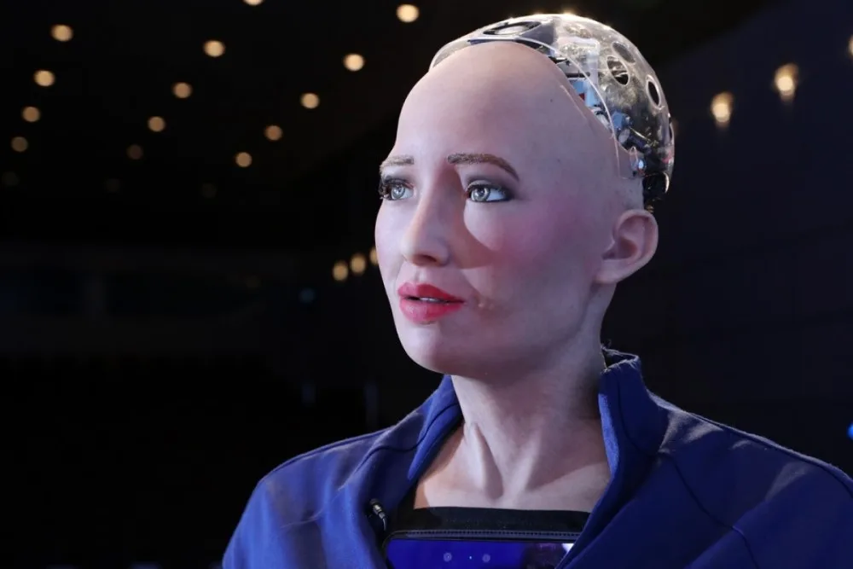

***What can be done now?***

There are many things that robots can be done now:

1. Making dinner/ drinks

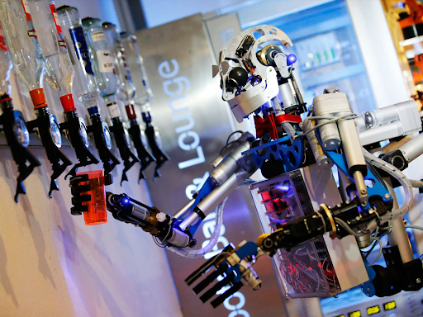

- On the Royal Caribbean cruise, the customer can enjoy the cocktail made by the bartender robot. According to “10 jobs robots already do better than you” by Catey Hill, the robot can make two drinks within minus which means in one days, the machine can make up to 1000 drinks.

[Link to the video!](https://youtu.be/mKCVol2iWcc)

- Developed by Moley Robotics’s company, the first cooking robot has been created. The robot contains automatic arms that follow the movement of the real master chef and make dishes based on the downloading recipe

1. Air delivery blood

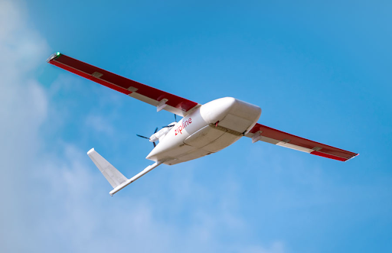

- The company in San Francisco has developed the automatic drone called Zipline that can deliver blood and medicine with the top speed of 128 kilometers for an hour. This can help many countries lacking healthcare service approach the basic necessities.

1. Delivering packages

[Link to the video!](https://youtu.be/U8Iey_wfo0I)

- Ford which is well known for car manufacture is currently developing a robot called Digit to deliver packages to customers' doorsteps. This robot can carry the package up to 40 pound and it can climb steps or stay balanced if it’s bumped according to “Ford's delivery robot walks like a human” by Matt McFarland.

1. Composing music

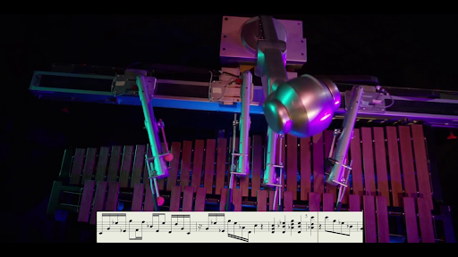

- Developed by Georgia Tech, the robot with the four arm marimba playing called Shimon uses the deep learning techniques to collect the dataset from well musicians and then perform its own original compositions.

1. Serving things

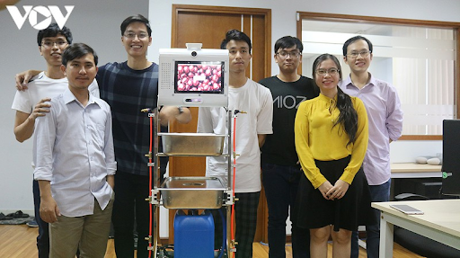

According to “DaNang online”, during the out-break of COVID pandemic, a small group of students in Ho Chi Minh City has developed a robot that can deliver things automatically to reduce the interaction between people which means it can decrease the spreading of coronavirus. The main functions of these robots is to sterilize, deliver food, medicine from outside to patients’ rooms.

1. Exploitation

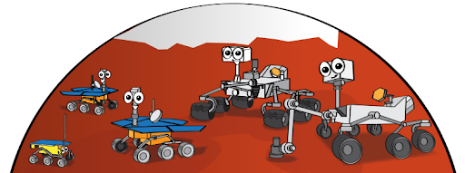

- According to Nasa, they have currently sent four robots called Rovers to Mars. These robots with the specialized wheels help the scientists to identify what parts of the planet is made of since Mars is made of various kinds of rocks and in each rock, there is a combination of chemicals.

***What is likely to be done in the next 3 years?***

1. Healthcare robot

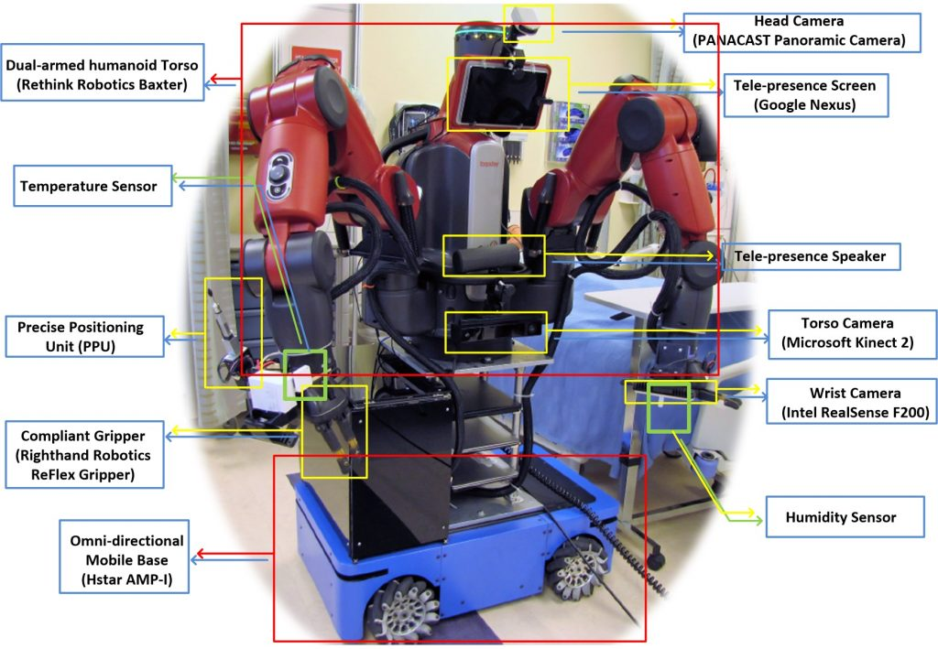

- According to “How Medical Robots Will Help Treat Patients in Future Outbreaks” by Kris Hauser and Ryan Shaw, they predict in the future the healthcare industry will have the participation of robotics and telemedicine called tele-nuring. Tele-nursing is an idea that nurses control the robot to do tasks relative to patient care since it reduces the rate of getting infected and improves social distancing.

1. Robots as co-workers

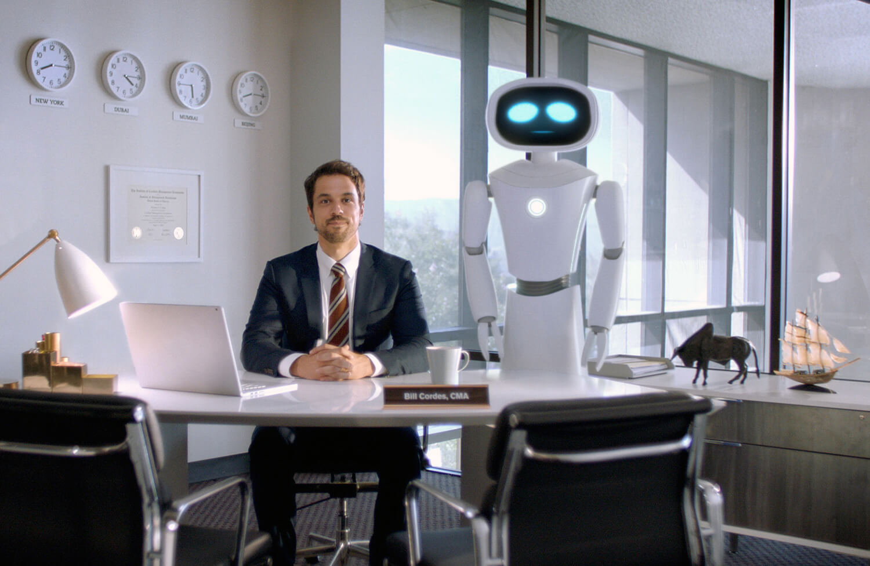

- In the future, robots might take multiple roles in the companies such as scheduling the meeting, sending the document to the specific people, etc just by giving the command. According to Nikolas Badminton, the futurist expected the workplace to developed in this way: “You’re probably going to walk into an office and your system’s been churning over the last couple of hours considering what’s been going on in business, your role, your job, what you need to do that day, and probably offer up several ideas about the right direction of what to do”

1. Robot in public security

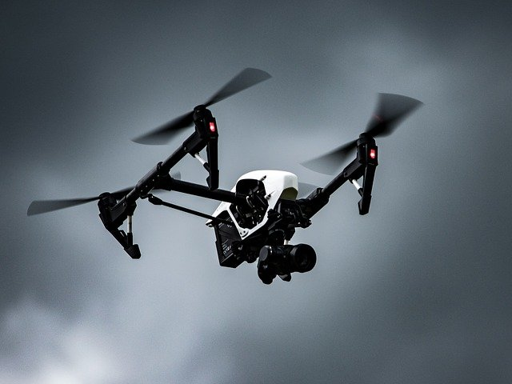

- According to “Smarter Robotics Are Changing Security”, in the near future, drones will have an important role in security since they are small and maneuverable. They can send accurate real time data and analysis to professional people if the location might not be unreachable so they can catch up what is happening and take action right away which means this can reduce the rate of accidents from happening.

***What technological or other developments make this possible?***

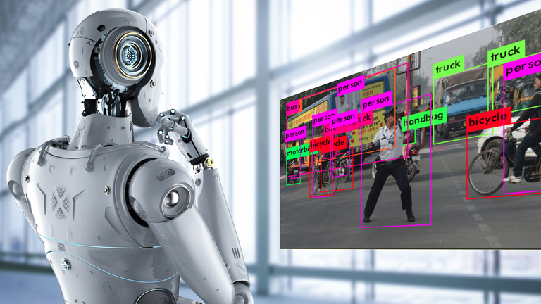

The development of Machine Learning makes a huge impact on the progress of robot development. Although Machine Learning is not the key factor in contributing to the physical side of robots, it holds an important role in improving the “brain” of robots. Through trials and errors, it helps robots master the works given to them and maintain that perfection for every product. Machine Learning (AI) also give robots the intelligence they need to respond to the unpredictable changes around them when they get deployed into the field. For example: According to Daniel Faggella, there are several applications of Machine Learning in Robotics (Faggella, 2020)

**In machine learning, the application to make this possible might be**

1. Computer Vision

According to Wind River in “COMPUTER VISION AND ROBOTICS EXPAND INDUSTRIAL CAPABILITIES”, computer vision helps robots to use cameras or scanners. Then it will analyze and extract useful information from the image and video(Wind River 2020). As a result of that, robots can recognize the object and perform the task well. The example of it, might be AnyMal or Spot by Boston Dynamics. The robots, with the use of computer vision, can sensor the environment around, detect and notify dangerous situations.

For extrasensory technologies such as radar, lidar, and ultrasound are being developed containing 360-degree vision-based systems for autonomous vehicles and drones.

1. Imitation Learning

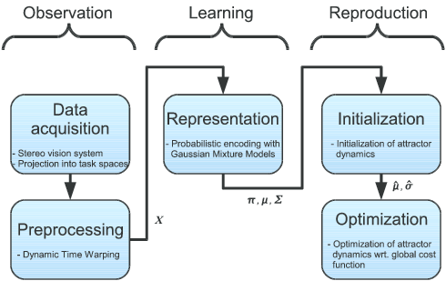

According to “Imitation Learning in Robots” by Billard A and Grollman D, imitation learning is the method to learn and develop new skills by observing it from other agents. This technique applies in robots to reduce the complexity of search pace for learning. With these techniques, robots can perform the tasks like an expert ( Billard A and Grollman D 2012 ). The example of it is the first robot cooking - Moley. This application can make the healthcare robots which I mentioned below become possible by imitating the movements of doctors, nurses, or surgeons. As a result of that, the surgery occurs more prosperous and reduces painful accidents during the process.

1. Assistive and Medical Technologies

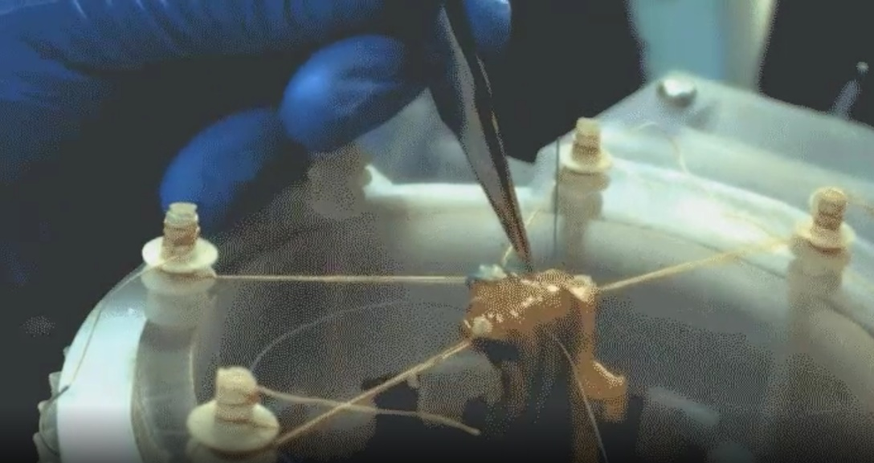

According to Will Knight, the researchers at Children’s National Health System in Washington, D.C. have developed a robot surgeon to perform stitching on its own. The stitching process of real surgeons is copied and stimulated into the machine with the help of Machine Learning (Knight, 2016).

1. Self-Supervised Learning

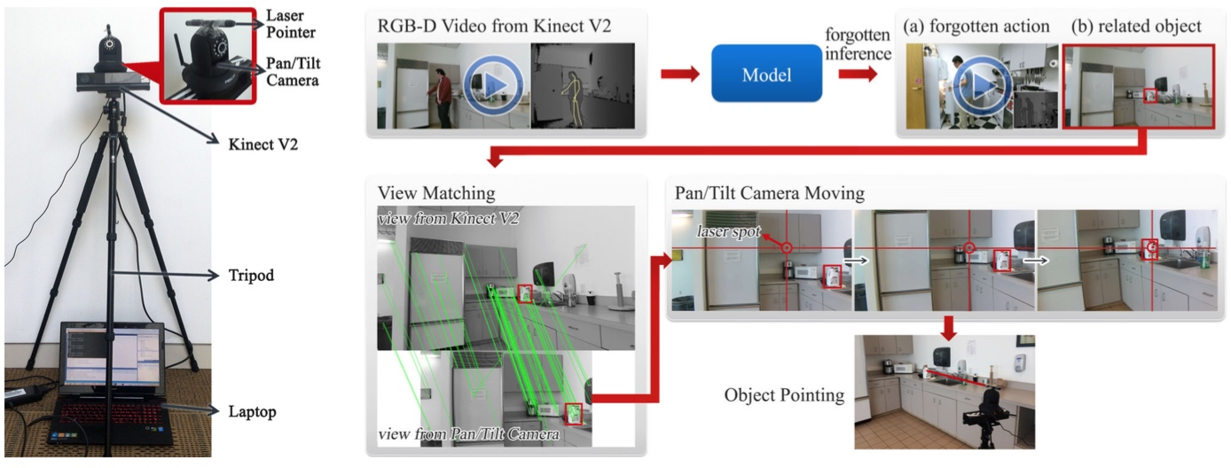

According to Evan Ackerman, Watch-Bot, a project that created and manage by researchers from Cornell and Stanford, is a self-learning machine that records normal human activities in a kitchen. The machine later analyzes the patterns and notify the people in that household with reminders. For example, if the person forgets to take the food out of the microwave, the machine will send a reminder about that incident (Ackerman, 2016).

***What is the likely impacts?***

In education

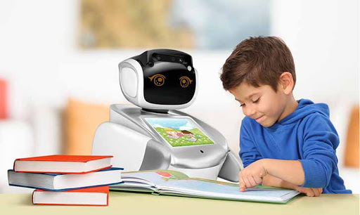

* Robot can be a teacher or a peer learner since the teachers cannot have capability to monitor and provide enough careness for all the students. Therefore, with the help of robots, the student will meet the necessary requirement of personalized learning.
* The most affected group of people are young people, especially toddlers. According to the research “Sociable robot improves toddler vocabulary skills” conducted in 2009, the use of robots in the classroom had significantly improved vocabulary skills of 18-24 months toddlers.
* Robot in education is not replacing the teacher since robots do not have any social skills and other human’s capabilities such as empathy, judgement, etc.

At home

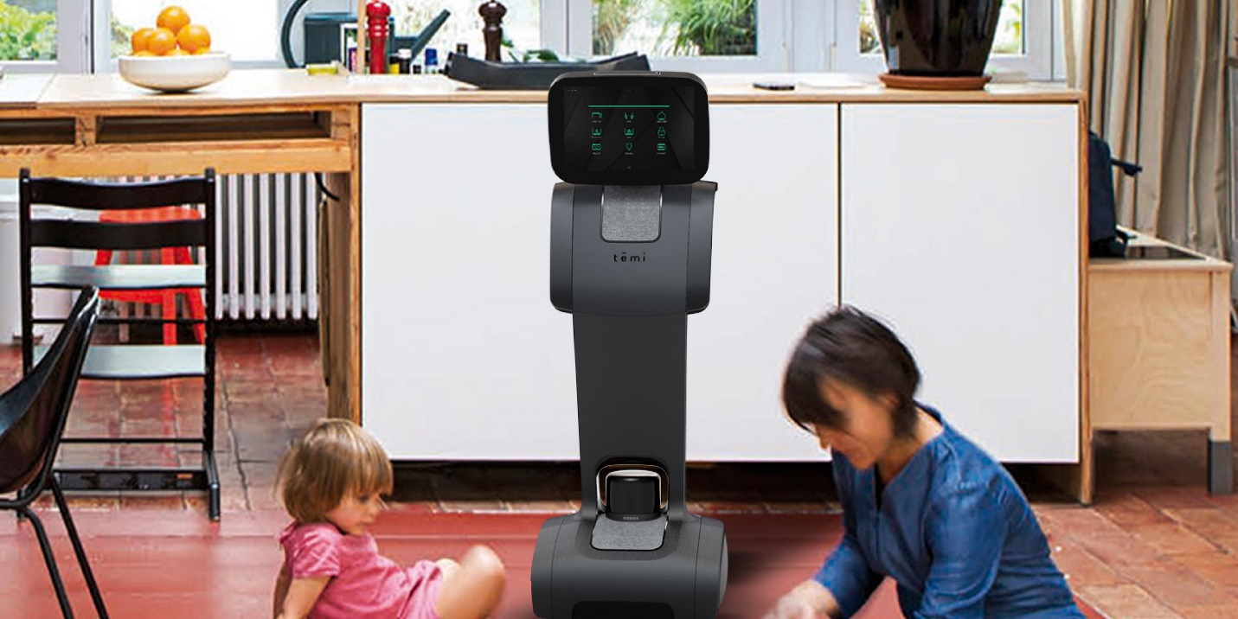

* Home security robot: Robots can guard your home while you are away by detecting faces, recognizing suspicious sounds, and alerting the owners if there is an intruder. Another company called “Deep Sentinel” has been taking this field to the next level by developing a security robot that can predict and prevent crime from occurring. It will immediately alert the owner in real time and contact to the police right away
* Domestic robot: Besides being the security guard, robots can help us to do the housework which saves us a lot of time. We can set the time to the vacuum cleaner to clean the house before we get home. Moreover, according to “The World's First Home Robotic Chef Can Cook Over 100 Meals” by Eustacia Huen, robots can help us cook the meal faster based on the recipes downloading on the internet and then clean up after itself too.
* Robot guarding at home is mostly affecting the house owner since it keeps not only their home but also their family members safe. The robot also helps the police reduce the number of crimes and prevent painful accidents. Although this can boost our productivity, it cannot replace the security guard or the police officer since the robots just can be in charge of the dull and repetitive duty while humans can do the complex, stimulating tasks.
* About the domestic robot, the most affected people might be the busy person since it helps to keep the house clean and helps them to stay healthy by preventing them from eating outside. Domestic robot such as a cooking robot cannot replace chefs since creating dishes needs creativity and robots can do that, it just can follow the instructions of the recipe. However, in the future, with the numbers of using domestic robots, there will be redundancy in the normal cleaning vacuum, washing machine, ironing, cookers, etc since the multi-function robots contain all of those in one machine.

***How will this affect you?***

In the future, life will be more advanced compared to the main time, and the most vital thing that took part in this revolution is robotics, and things that had the most impact are humans which include our friends, family and ourselves. In fact, our lives now have been depending on robots a lot. First of all, the thing that must be discussed is our daily life or mundane activities at home. For example, we used to walk around the house with a vacuum cleaner, and that action is really exhausting especially for women.

Therefore, a vacuum robot has been created which oversees cleaning the house surface, it can be manipulated by far with an application from the phone. In the future, our reliance on the robots will be unchangeable, this resulted in working away from home. You will not have to worry about the hygiene in your house, this term will be completely accomplished by the household chores robots. Furthermore, shopping will be easier for us, this resulted in delivering products to our house with a drone.

Moreover, we usually go shopping with our friends or with family, sharing things and discussing together. But in the future, there is no such a thing, and it will be difficult for us to adapt, especially for the young generations. People in the late generations – which have more difficulty in adapting to the new things because they have been interacting with the current world for a long time. Unlike the old generations, the younger generations seem adapting to those change much easier, this results in the curiosity they have. Young people always want to try things that are new and strange, in fact they are addicted to it, willing to test it and share it with others. For middle-aged people or above, the term robot is such a whole new thing to them, but for young generations like us is more like absorbing new knowledge.

***Project Ideas***

**Overview**

My project would be a web application called CodeX that could help users in Vietnam learn how to code and program. This application will provide many walkthrough tutorials to learn different programming languages such as C++, Java, Python, etc. Moreover, at the end of each session, to know if the users understand what they have learned, CodeX will provide several quizzes to help users remember the course easier. Besides that, it will have many mentors available for you to ask how to start coding, which is the best language for you to learn. Moreover, you can match with somebody that starts the same program path as you. Therefore, you can learn something new from others and tell them about what you have learned, because one of the best ways to learn something is teaching it to somebody else. If you finish our tutorials, there are many challenges or pet projects to do as practice makes perfect.

**Motivation**

We are now standing on the brick of four industrial revolutions. Therefore, the demand of computer and information technology has been currently increasing. According to VietNam’s News, Viet Nam needs more than 400,000 information technology (IT) in 2020 and this number will become greater for the next 10 years. Not all Vietnamese people have the chance to study English so learning through video tutorials or reading documents is quite hard for them to understand especially for the young. This application will be the essential tool for their start of exploring the IT world. Moreover, for those who want to change their career path to IT or lost basic knowledge about IT, CodeX provides many courses which take 3-4 hours to help them keep back on track.

**Description**

***1. Programming language***

This feature will help users to choose the programming language they want to learn. If there are difficulties in picking the language, there will be a small survey asking about their career path and some recommendation will be given to users. Users can choose many languages as they want

***2. Definition and example***

Between tutorial walkthrough, there will be definitions and syntax with relevant examples to the course. This help users to have an overview look and basic knowledge of what they are going to learn

***3. Online interpreter***

After knowing the overall of the basic syntax, this feature will help users apply directly what they have learnt from the lessons by doing some given exercise on this online compiler insteading of installing others IDE like VisualCode, PyCharm,etc and do it on those.

***4. Quiz during the course***

After the tutorial, there are some quizzes provided to help users to review the lessons. Therefore, they will memorize it easier and it also makes sure that they understand the lessons correctly.

***5. Course career path***

This feature will help them to learn which programming language is best for their career. For example, if users want to be web developers, the course of this included HTML, CSS and Javascript. If they want to be a DataScience, the course should include Python, SQL, C++, etc.

***6. Mentors and forum***

Some challenges while practicing might be difficult and confused to the users. Therefore, they can connect to our mentors to know what their problems are or what they do not understand clearly. Moreover, we also have a forum for developers to chit chat or to find someone that has the same career path to learn and get along with each other.

***7. Pet project***

After finishing the course, there are many projects to do such as making the E-commerce website, Rest API, chatbot,etc to develop your skill. Moreover, users can show this project to the companies that they apply to have a high chance of recruitment.

***8. Hackathon, Competition***

Every week, the online coding contests are organized. It can be individual, or users can form the team to participate in the competition. This feature not only helps users to apply what they have learned but also to know their ability. Therefore, they can modify the study plan to develop themselves. Furthermore, the best thing about joining the competition is that users can expand their networking. They will know more people and learn new things from others.

***9. Recruitment***

This feature is the service which helps developers who are seeking for a job or finding an internship. There is going to be a range of job recruitments from web developers, game developers,full stack,etc which depend on what users’ career path are. Moreover, CodeX also provides the feature “Job near you” so it will make users easy to search things. This not only provides jobs in Vietnam, if developers want to have an opportunity to work overseas, there will be jobs available for them too.

**Tools and Technologies**

Software: This application will be developed using HTML, CSS and Javascript to build a web application. Besides, to store the data of the customers or the service itself, it would also be used MongoDB or SQL and PHP. Moreover, for creating the online interpreter, I can use the API of the third service such as Hackkerank or HackerEarth.

Hardware: To store thousands of thousand data, there would be lots of hard disk. Beside from that, to provide better experiment for the customers, it should have a good RAM since it has a lot of feature which may slow down the application

**Skills Required**

Hard-working: I think this is the most important skill to be an IT employee. If I don’t have this skill, the project will be procrastinated and never be done. Therefore, the project may be failing

Patient: Beside the hard-working, there I should be patient too because I have to work under a lot of pressure which may decrease my motivation toward the project. Being patient can get me overcome it and get back on what I started

Technical in HTML, CSS, Javascript, MongoDB and some other programming languages: Those languages are the main core if I want to build up CodeX. As a result of it, without that skill, I cannot do anything.

**Outcome**

If CodeX is successful, there might be more and more people working in the IT industry which meet the requirement of this career for the next 10 years. Therefore, the IT industry in Vietnam will be developed and reached to the position that could be compared to other developed countries such as China, America, Russia, etc. Consequently, robots for housework which helps saving time, self-driving cars which are very useful for those who do not know to drive cars, virtual assistants like Jarvis in Marvel movies to arrange your work... those things in the next 5 years might be common in Vietnam. Finally, with those services made in Vietnam, it can be bought from other countries which can bring benefits for Vietnam’s economic efficiency.

***Feedback***

**Tuan's Feedback**

***Feedback on myself***

* As a team leader, I am ashamed of how I have performed in our group. This is not about the content of my work, but rather about how I deliver it. Due to my tight schedule, I have been late quite often, on delivering my works to the group. The problem is that I failed at communicating with my team members about the issue and this led to a lot of stress to my peers. I am responsible for my actions and I owe them an apology.

***Feedback on team members***

Quynh Ngo (s3836322)

* She has been a great team member to the group with her amazing dedication and responsibility. She always finishes her work on time and encourages others to finish the assignment.

Ky Anh (s3812288)

* Although Quynh and I have already known each other before Anh joined us, he did not hold back and blend in right away without any complaints. His works might need some improvements here and there, but overall, the final product is quite decent.

**Anh's Feedback**

***Feedback on myself***

* Advantages: The only advantage that I possess is persistence. Although my coding skill is not the best, but I am always enhancing my skill overtime. When I am facing a problem from coding such as making a website or practicing with Python, I often find a solution by myself or observing solutions from any IT forums.
* Disadvantages: Although I am only studying this course for a few months, therefore I have not participated in any complementary courses from outside. In facts, my coding skill is not as strong as other peoples. When coding for our group website, is just a simple page with pictures and words in it. Furthermore, I lack in communication skill. When I confront any problems in coding the website, I do not ask my team members for help or any advice which makes it difficult for me to code.

***Feedback on team members***

Quynh Ngo (s3836322)

* Advantages: Quynh coding skill was good; we can see her potential when looking at her website. Furthermore, she always encourages others team member to push them forward. Despite that our team only contains 3 members, Quynh can providing each task for each member separately and equally, so that there will be no conflicts between teammates. Nevertheless, Quynh always willing to help other members regards what the tasks is, she also the person who gives me advices on my coding skill, she taught me how to make the coding sections more readable by providing comments so that when peoples inspects my code their can navigate each sections easier. Quynh writing skill is amazing, she can express and give a clear definition when writing, it can be easily seen by looking at her project ideas. The functions and features were described very detail.
* Disadvantages: Although Quynh navigation skill and her writing skill is beyond expectation, the only weakness is she lack in communication. Within teammates there is no problem, but when asking questions with other peoples she cannot express the main points of the questions, this resulted in the answers were not good as expected.

Nguyen Thanh Tuan (s3836455)

* Advantages: Tuan has a good leadership and especially communication skill. Because of this our interview was beyond expectation. He provides questions that ask directly to the main point and the answers we received were valuable. Furthermore, Tuan report also very credible and all the sources were reliable. He also uses a lot of academic words which makes his report look very professional. Nevertheless, each sections of Tuan report fulfill all the requirements of the questions.
* Disadvantages: Is very difficult to find any disadvantages from Tuan.

**Quynh's Feedback**

***Feedback on myself***

* Advantages: When I worked as a member of the group, I always tried my best on everything such as design web which you can see my effort when you look in our group website. The website was not perfect, but I will try to improve my skills in the near future. About my work in writing the assessment, I followed most of the requirements section. Moreover, when the deadline was set for a different task, I did it on time.
* Disadvantages: I think I lack communication skills since when I wanted to ask some questions in the interview, I could not express that. As a result of it, we missed communication and received a question that was not as I expected. Moreover, I am bad at writing reports, so this is what I need to improve since when I write these feedback on myself, it takes me two days just to write all these lines. As a result of it, my report did not include many academic words which made my report less professional.

***Feedback on members in the group***

Giang Ky Anh (s3812288)

* Adavantages: When I work with him, I am quite impressed by his web developed skills since I have learned a lot of new things when I looked into his code. For example, I have learned “ins” to underline the work or “dl” to define the description list and also his code looks very clean with a lot of comments. Therefore, when we combined our code together, I could understand his code. Moreover, when I read his report about the blockchain, I can have an insight view about it since besides giving the definition, he also gave many reality examples and many pictures to demonstrate his view. His structure to perform the report looks clean, easy to read and includes all the requirements. Besides the assessment, I think he is working well in the group and has good communication skills toward the member.
* Disadvantage: Hard to point out what is wrong in his work.

Nguyen Thanh Tuan (s3836455)

* Advantage: Firstly, he has the greatest skills in communication in our group. Thanks to him, the interview occurred well and all the information we received was valuable. Moreover, I was very impressed when I read his report, all the information given was detailed and the sources he found were reliable. The report looks clean, professional since it includes a lot of academic words that I have to do some research to understand his point of view. Moreover, the report follows most of the requirements. Furthermore, the code is written clean and included a lot of comments, so it makes his code readable. He also is the one who advised me to write the code more efficiently and not waste much memory.
* Disadvantage: It is hard to find his disadvantage in his assessment and his attitude toward the group.

***Group Reflections***

**Tuan's Reflections**

In my opinion, our group did well on the content for the assignment. I believe most of it is quite decent and meets the requirements and expectations of the assignment. We also did well on communicating on planning and dividing the works to each member. However, in terms of communication, I need to plan my schedule more efficiently and talk with my team members about the issue. We also need to plan ahead more and leave breathing room in between (these somewhat tights back to my fault about communicating). Another thing our group needs to improve is how we link our works together as the writing style and wordings of our team members are quite different. I am surprised at how my team members are so forgiving despite my irresponsibility. Once again, I owe them an apology. The good thing is that I am still able to put in my work, so it does not affect the group’s grade. Quynh and Anh have a lot of good characteristics that I can learn and follow. I will take this assignment as a lesson to improve myself and redeem their faiths on me in the next assignment.

**Anh's Reflections**

The first time I worked in a group was not as good as I expected, each member including me have different characteristics. Therefore, this differentiate was a challenge for us, if we cannot know each other’s well, then we do not know how to provide suitable task for each person. However, after working together for 3 weeks, we have known each other’s and turns out everything were beyond my expectation. We scheduled the plan and choose time for meeting; therefore, we have 4 meeting in total.

After clarifying each other firmly, we then start the first meeting. The first one is presenting team members projects idea and ideal jobs, then we start to hand out each task for each person in the group, by providing suitable task for each member, the last three meeting were going on well without occur any problems. Rather than a group of 4 like other groups, our group only contains up to 3 members, so this resulted in each of us have more work to do before the deadline.

At first, I thought that this is too much work but with Quynh helps, she has providing suitable task for each person according to everyone strength, so this was going well after that. Furthermore, Quynh and I were designer for our website; therefore, my coding skill is only for beginners but Quynh has helped me a lot in this area and I have acquired more knowledge in coding. Therefore, I need to improve my coding skill and knowledge so I can help my team member a lot more.

**Quynh's Reflections**

When I first worked in the group, everything was a bit difficult since each person has a different characteristic, so we have difficulty in understanding each other's thoughts and perspectives. However, having worked with each other for 3 weeks, turns out everything is great, we know which people are suitable for the task so each member can use their strength to do the task well. For example, I have difficulty in having conversations with other people. Therefore, Tuan or Ky Anh can do the interview section and give me the task that can show my strength. Even everything seems great, one of the things that our teams need to improve is not procrastination. Up to the day of the deadline, not all of us could do it on time so we currently had to move the deadline to the next day. Fortunately, every work was done perfectly on the new setting date (thanks god). During our cooperation, there are several things that surprised me which is the mysterious power to do the report. One of our members, apologizing that I cannot mention the name since it would cause him a lot of trouble, had done the report more than 5000 words within a day before the deadline. I am quite impressed because for me, to write the report for more than 5000 words, it takes me 6 days to plan an idea, find a source and write it on my own word. Meeting each other, I have learned a lot of things, especially soft skills for example how to do the report within a day or how to find source and information in effective ways. This is an important skill since when I google, I meet a lot of sources and not know how to classify it, with the help of my teammates when google, I not only save time in finding information but also finding the source that is reliable using google scholar.

**Group Reflections**

In overall, the TAQ team at the beginning confront many difficulties. With the differentiate in characteristics of each member; therefore, they cannot provide a suitable task for them. However, things have moving in a positive way.

The first meeting has been scheduled, the purposes of this meeting is to introduce each member project ideas and ideal jobs. After this first meeting, each person chooses a topic of their own and searching for sources before start to work on it. After choosing topics, the team leader – Tuan has creating a share drive so each member can contribute their task separately in the folder. Each member contributed their works orderly which namely Team Profile – in Team Profile section, the TAQ team must share their 3-learning style test and their ideal jobs. This process could help member in the group known each other more clearly.

The second section has been replaced with Industry Data because the Tools section is related to interviewing, so it has been done later. In Industry Data, each member in individual must provide their Top Generic Skills, Top IT Skills, and Top Job Titles and named what rank they were. This section was a bit difficult because some of the team member skill does not ranked in the Burning Glass Data or the skills name were different. This problem has been easily solved by searching for they own skills or jobs accordingly to the provided data.

After finishing the first section and second section, the TAQ team begins to work on the IT Technologies section. Although the team lack in the number of team member, each person has decided to choose one of their own topics as they had pick before and after finishing the selected topics, the members then will choose the fourth one and working on it together. The TAQ team has confronting many difficulties on this section.

Some of the chosen topic was very hard to find a source with high credibility, there for one of the members do not know how to find a trustworthy source before but the others have helped to solve this issue. Because the time spent on finding the source was enormous, it took half of the week to complete finding sources and start to write a report. Therefore, a member in the team has some personal problem and cannot complete the section to the date. The team has confirmed that this cannot be done before the deadline, however every team member of TAQ team has try their best and completed all the section perfectly.

For the Tools or interview section, Tuan with his amazing communication skill has set up a meeting with some IT professional and start to interview them, he had given out the questions which asked directly to the main point so the information that TAQ team gathered was beyond their expectation.

Furthermore, after completing all the sections above, the team has enacted a meeting for Project Ideas section. Each member introducing their own ideas, then they contrast it before choosing which ideas will be chosen. All the ideas were perfects to select, but the ideas of Tuan were hard to be deployed and Ky Anh projects was an application on phone so therefore, they do not acquire any skill to make an app. The TAQ team has make a final decision and the chosen one was Quynh project idea, which is an online learning website.

The Feedback and Group Reflection section was done perfectly by each member in the team and there is no issue in it. For creating the group website, Quynh is the person who in charge of giving other member a suitable section for them to code. After finishing the coding for each section, the member will then push it to Github and share the code to other. By giving each person a section to code instead of one person handle the coding section, this action can make sure that each member has contributed to the log of activities.

***Reference***

**Virtual Dispersive Networking – Cyber Security**

1. J. Bloomberg. "Cybersecurity: Turning the Tide on Hackers with Dispersive Technologies" forbes.com. https://www.forbes.com/sites/jasonbloomberg/2014/10/16/cybersecurity-turning-the-tide-on-hackers-with-dispersive-technologies (accessed Aug. 28, 2020).
2. Engineer Ambitiously. "Understanding Spread Spectrum for Communications" ni.com. https://www.ni.com/en-vn/innovations/white-papers/06/understanding-spread-spectrum-for-communications.html (accessed Aug. 28, 2020).
3. Dispersive Networks. "SASE The Future of Network & Security" dispersive.io. https://dispersive.io/sase/ (accessed Aug. 28, 2020).
4. Dispersive Networks. "ClearBlade and Dispersive Partner to Accelerate and Secure IoT Edge and Cloud Deployments" dispersive.io. https://dispersive.io/2020/07/21/clearblade-and-dispersive-partner-to-accelerate-and-secure-iot-edge-and-cloud-deployments/ (accessed Aug. 28, 2020).
5. Dispersive Networks. "Envistacom and Dispersive Partner to Conquer New Challenges in Securing Government and Military Networks" dispersive.io. https://dispersive.io/2020/02/25/envistacom-and-dispersive-partner-to-conquer-new-challenges-in-securing-government-and-military-networks/ (accessed Aug. 28, 2020).
6. R. Conklin and B. Murray, “SECURING ENTERPRISE BLOCKCHAIN WITH SDN” Dispersive Networks, Alpharetta, GA, USA, 2019. [Online]. Available: https://bcnfusion.io/wp-content/uploads/2019/10/D19_WP_Blockchain_091119.pdf
7. Blockchain Network Fusion. "The Right Networks Make BLOCKCHAINS MORE SECURE" bcnfusion.io. https://bcnfusion.io/ (accessed Aug. 28, 2020).
8. Dispersive Networks. "Our Innovative Approach: Setting new benchmarks for performance and security." dispersive.io. https://dispersive.io/technology/ (accessed Aug. 28, 2020).

**Blockchain and Cryptocurrency**

1. Grabowski, M 2019, Cryptocurrencies : A Primer on Digital Money, Taylor & Francis Group, Milton. Available from: ProQuest Ebook Central. [14 August 2020].
2. Nofer, M., Gomber, P., Hinz, O. & Schiereck, D. 2017, "Blockchain", Business & Information Systems Engineering, vol. 59, no. 3, pp. 183-187.
3. J.J.P.C. Rodrigues, R. Hsing, M. Chen, B. Jiao, B. Vaidya, Guest editorial on vehicular communications and applications, Journal of. Network and. Computer. Applications., Vol. 36, PP. 1273–1274, March 2011.
4. Zhang, M. & Ji, Y. 2018, "Blockchain for healthcare records: A data perspective", PeerJ PrePrints, .
5. Tsung-Ting Kuo, Hyeon-Eui Kim, Lucila Ohno-Machado, Blockchain distributed ledger technologies for biomedical and health care applications, Journal of the American Medical Informatics Association, Volume 24, Issue 6, November 2017, Pages 1211–1220, https://doi-org.ezproxy.lib.rmit.edu.au/10.1093/jamia/ocx068
6. Mathusudan, S. & Kim, S. 2018, “Branch based blockchain technology intelligent vehicle”, vol. 145, p. 219-231

**Machine Learning**

1. "What is Machine Learning? A definition - Expert System", Expert System, 2020. [Online]. Available: https://expertsystem.com/machine-learning-definition/. [Accessed: 07- Aug- 2020].
2. "Naive Bayes classifier", En.wikipedia.org, 2020. [Online]. Available: https://en.wikipedia.org/wiki/Naive_Bayes_classifier. [Accessed: 07- Aug- 2020].
3. R. S. Brid, "Decision Trees '' — A simple way to visualize a decision", Medium, 2020. [Online]. Available: https://medium.com/greyatom/decision-trees-a-simple-way-to-visualize-a-decision-dc506a403aeb. [Accessed: 07- Aug- 2020].
4. "Random forest", En.wikipedia.org, 2020. [Online]. Available: https://en.wikipedia.org/wiki/Random_forest. [Accessed: 07- Aug- 2020].
5. "AdaBoost", En.wikipedia.org, 2020. [Online]. Available: https://en.wikipedia.org/wiki/AdaBoost. [Accessed: 07- Aug- 2020].
6. "Support vector machine", En.wikipedia.org, 2020. [Online]. Available: https://en.wikipedia.org/wiki/Support_vector_machine. [Accessed: 07- Aug- 2020].
7. W. Li, N. Narvekar, N. Nakshatra, N. Raut, B. Sirkeci and J. Gao, "Seismic Data Classification Using Machine Learning," 2018 IEEE Fourth International Conference on Big Data Computing Service and Applications (BigDataService), Bamberg, 2018, pp. 56-63, doi: 10.1109/BigDataService.2018.00017.
8. G. Hinton et al., "Deep Neural Networks for Acoustic Modeling in Speech Recognition: The Shared Views of Four Research Groups," in IEEE Signal Processing Magazine, vol. 29, no. 6, pp. 82-97, Nov. 2012, doi: 10.1109/MSP.2012.2205597.
9. P. Allison, "What does a bomb disposal robot actually do?", Bbc.com, 2020. [Online]. Available: http://www.bbc.com/future/story/20160714-what-does-a-bomb-disposal-robot-actually-do. [Accessed: 07- Aug- 2020].
10. "Google computers trained to detect breast cancer", Mercurynews.com, 2020. [Online]. Available: https://www.mercurynews.com/2017/03/03/google-computers-trained-to-detect-cancer/. [Accessed: 07- Aug- 2020].
11. "3 Ways to Automate Marketing with Machine Learning", TOPBOTS, 2020. [Online]. Available: https://www.topbots.com/marketing-automation-machine-learning-applications/. [Accessed: 08- Aug- 2020].
12. "3 Resume Screening Tools Every Recruiter Should Know About | Ideal", Ideal, 2020. [Online]. Available: https://ideal.com/resume-screening-tools/. [Accessed: 08- Aug- 2020].
13. "The Potential Impact of Machine Learning in Healthcare | RX4 Group", RX4 Group, 2020. [Online]. Available: http://rx4group.com/the-potential-impact-of-machine-learning-in-healthcare/. [Accessed: 08- Aug- 2020].
14. I. Wladawsky-Berger, "What Machine Learning Can and Cannot Do", Medium, 2020. [Online]. Available: https://medium.com/mit-initiative-on-the-digital-economy/what-machine-learning-can-and-cannot-do-6788a818776. [Accessed: 11- Aug- 2020].
15. K. Sennaar, "How America’s 5 Top Hospitals are Using Machine Learning Today", Emerj, 2020. [Online]. Available: https://emerj.com/ai-sector-overviews/top-5-hospitals-using-machine-learning/. [Accessed: 12- Aug- 2020].
16. "15 Ways Machine Learning Will Impact Your Everyday Life", EliteDataScience, 2020. [Online]. Available: https://elitedatascience.com/machine-learning-impact. [Accessed: 12- Aug- 2020].
17. N. Ostdick, "How Machine Learning Impacts Manufacturing and Logistics", Blog.flexis.com, 2020. [Online]. Available: https://blog.flexis.com/how-machine-learning-impacts-manufacturing-and-logistics. [Accessed: 12- Aug- 2020].
18. S. Rose, "What is the Future of Machine Learning?", Medium, 2020. [Online]. Available: https://codeburst.io/what-is-the-future-of-machine-learning-f93749833645. [Accessed: 14- Aug- 2020].
19. "Facial recognition system", En.wikipedia.org, 2020. [Online]. Available: https://en.wikipedia.org/wiki/Facial_recognition_system. [Accessed: 28- Aug- 2020].

**Robots**

1. J. R. Movellan, M. Eckhardt, M. Virnes, A. Rodriguez, Sociable robot improves toddler vocabulary skills, in Proceedings of the 4th ACM/IEEE International Conference on Human-Robot Interaction (ACM, 2009), pp. 307–308.
2. E. Huen, "The World's First Home Robotic Chef Can Cook Over 100 Meals", Forbes, 2020. [Online]. Available: https://www.forbes.com/sites/eustaciahuen/2016/10/31/the-worlds-first-home-robotic-chef-can-cook-over-100-meals/#3dfbd9537228. [Accessed: 13- Aug- 2020].
3. C. Hill, "10 jobs robots already do better than you", MarketWatch, 2016. [Online]. Available: https://www.marketwatch.com/story/9-jobs-robots-already-do-better-than-you-2014-01-27. [Accessed: 13- Aug- 2020].
4. Báo Đà Nẵng, 2020. [Online]. Available: https://baodanang.vn/khcn/202008/robot-van-chuyen-tu-dong-ra-doi-trong-mua-covid-19-3600948/. [Accessed: 13- Aug- 2020].
5. "The Mars Rovers | NASA Space Place – NASA Science for Kids", Spaceplace.nasa.gov, 2020. [Online]. Available: https://spaceplace.nasa.gov/mars-rovers/en/. [Accessed: 13- Aug- 2020].
6. C. Matt McFarland, "Ford's delivery robot walks like a human", CNN, 2019. [Online]. Available: https://edition.cnn.com/2019/05/22/tech/ford-delivery-robot/index.html. [Accessed: 13- Aug- 2020].
7. K. Hauser and R. Shaw, "Full Page Reload", IEEE Spectrum: Technology, Engineering, and Science News, 2020. [Online]. Available: https://spectrum.ieee.org/automaton/robotics/medical-robots/medical-robots-future-outbreak-response. [Accessed: 14- Aug- 2020].
8. S. Huntington, "Smarter Robotics Are Changing Security | RoboticsTomorrow", Roboticstomorrow.com, 2020. [Online]. Available: https://www.roboticstomorrow.com/article/2020/01/smarter-robotics-are-changing-security/14735. [Accessed: 14- Aug- 2020].
9. Science Trek, “Robotics: Facts”, 2020. [Online]. Available: https://sciencetrek.org/sciencetrek/topics/robots/facts.cfm [Accessed: 27 - Aug - 2020]
10. W. River, "COMPUTER VISION AND ROBOTICS EXPAND INDUSTRIAL CAPABILITIES | RoboticsTomorrow", Roboticstomorrow.com, 2020. [Online]. Available: https://www.roboticstomorrow.com/article/2020/02/computer-vision-and-robotics-expand-industrial-capabilities/14749/#:~:text=One%20way%20to%20increase%20robotic,its%20surroundings%20and%20mimicking%20sight. [Accessed: 28- Aug- 2020].
11. Billard A., Grollman D. (2012) Imitation Learning in Robots. In: Seel N.M. (eds) Encyclopedia of the Sciences of Learning. Springer, Boston, MA. https://doi.org/10.1007/978-1-4419-1428-6_758
12. Faggella, D., 2020. Machine Learning In Robotics - 5 Modern Applications. [online] Emerj. Available at: [Accessed 28 August 2020].
13. Ackerman, E., 2016. This Robot Uses Machine Learning To Take Care Of Absent-Minded Humans. [online] IEEE Spectrum: Technology, Engineering, and Science News. Available at: [Accessed 28 August 2020].
14. Knight, W., 2016. Nimble-Fingered Robot Outperforms The Best Human Surgeons. [online] MIT Technology Review. Available at: [Accessed 28 August 2020].